**Project Number:** 654220

**Project Acronym:** EUCALL

**Project title:** The European Cluster of Advanced Laser Light Sources

**Periodic Technical Report**

**Part B**

**Period covered by the report**: from [01/10/2015] to [31/03/2017]

**Periodic report:** 1st

# 0. Executive summary

The attached document comprises the 1st Periodic Report for the European Cluster of Advanced Laser Light Sources (EUCALL), which has received funding from the *European Union’s Horizon 2020 research and innovation programme* under grant agreement No 654220. At the end of the first reporting period, 10.10.2015 - 31.03.2017, EUCALL is a successful collaboration between members from the accelerator and laser communities. The project partners are motivated to work on common solutions, partly triggered by the very timely chosen objects of collaboration of high relevance to all participating research facilities. Project meetings have been held at participating facilities, and in demonstration of their success all project milestones and deliverables to date have been completed according to the defined schedule. EUCALL has also received and accepted requests from from two starting facilities to join EUCALL as associate partners. EUCALL’s Scientific Advisory Committee, a panel of external high level experts from the accelerator and laser communities, were positive about EUCALL’s objectives and achievements, and recommended that the collaborations formed within EUCALL be extended beyond the project duration.

# List of abbreviations used:

ALL-RI – Advanced Laser Light Research Infrastructure

EB – Executive Board

FEL – Free-electron Laser

FPGA – Field Programmable Gate Array

GPU – Graphical Processing Unit

HIREP – High Repetition Rate Sample Delivery (WP6)

OL – Optical laser

PUCCA – Pulse Characterization and Control (WP7)

RI – Research Infrastructure

SAC – Scientific Advisory Committee

SB – Synergy Board

SC – Steering Committee

SIMEX – Simulation of Experiments (WP4)

SR – Synchrotron Radiation

UFDAC – Ultrafast Data Acquisition (WP5)

WP – Work Package

WPC – Work Package Coleader

WPL – Work Package Leader

**Contents**

1. Explanation of the work carried out by the beneficiaries and overview of the progress 4

1.1 Objectives 4

1.2 Explanation of the work carried out per WP 8

1.2.1 Work Package 1 - Management of the EUCALL Project 8

1.2.2 Work Package 2 - Dissemination and Outreach 12

1.2.3 Work Package 3 – Synergy of Advanced Light Sources 14

1.2.4 Work Package 4 – Simulation of Experiments (SIMEX) 19

1.2.5 Work Package 5 – Ultrafast Data Acquisition (UFDAC) 25

1.2.6 Work Package 6 – High Repetition Rate Sample Delivery (HIREP) 29

1.2.7 Work Package 7 – Pulse Characterization and Control (PUCCA) 33

1.2.8 EUCALL Deliverables and Milestones 38

1.2.9 Publications from EUCALL or including EUCALL contributions 42

1.3 Impact 43

2. Update of the plan for exploitation and dissemination of results 43

3. Update of the data management plan 43

4. Deviations from Annex 1 and Annex 2 44

4.1 Tasks 44

4.2 Use of resources 45

Annex 1: SAC Report 2016 48

Annex 2: EUCALL Response to the SAC Report 2016 54

Annex 3. List of Activities and Events in EUCALL, First Reporting Period 56

# 1. Explanation of the work carried out by the beneficiaries and overview of the progress

# 1.1 Objectives

**The following high level objectives had been defined in the EUCALL proposal:**

O1 - Analyze and promote the efficient use of ALL-RIs

O2 - Identify and develop the combined research potential

O3 - Analyze and promote the innovation potential offered by the ensemble of ALL-RIs

O4 - Identify joint foresight topics in science and research policy, further strengthening the portfolio of advanced laser light source RIs within the ERA

O5 - Development and implementation of a simulation platform

O6 - Development of ultrafast data acquisition

O7 - Development of sample handling and positioning systems

O8 - Joint development of advanced diagnostics

EUCALL has during its first reporting period brought together many scientists and engineers from synchrotron radiation (SR), free-electron laser (FEL) and optical laser (OL) user facilities and research infrastructures (RIs). Following the well-prepared project launch and the successful kick-off meeting in October 2015, EUCALL members from the participating institutes have worked on many activities, have started joint developments, and have exchanged a huge amount of experience coming from their specific communities. All project milestones and deliverables have been achieved successfully within the first reporting period. These accomplishments highlight that EUCALL’s intention and goal in uniting the communities of accelerator- and laser-based light sources are timely and well achievable. These activities are resulting in significant technological developments and can be expected to strongly contribute to the harmonization and optimization of the landscape of advanced laser light research infrastructures (ALL-RIs) for photon science in Europe. In the following we describe briefly how the various work packages (WPs) of EUCALL have contributed to the achievement, or at least to the effort towards achieving EUCALL’s objectives in the course of the full, three year project.

Work towards the achievement of EUCALL’s Objectives O1-O4 has been carried out under WP3 “Synergy of Laser Light Sources”:

For Objectives O1 and O2, a Synergy Board (SB) was created which consists of experts in free-electron laser, synchrotron and optical laser radiation science. A data collection process has been completed over current instrumentation and photon beamlines relevant to the EUCALL scope and planned or already operational for user access at SR, FEL and OL facilities. These facilities included the EUCALL beneficiaries, but also a number of other facilities with high relevance. To broaden the level of comparison beyond Europe, a few relevant facilities in the USA and Japan were also included. The information collected was presented to the Synergy Board in fulfilment of Milestone 3.3. The SB presently analyses these data and also develops preliminary conclusions, in order to identify commonalities between the facilities, potential collaborations, but also missing elements. The SB will present its analysis of the data for discussion at the 2nd Annual Meeting in June 2017.

EUCALL’s Scientific Advisory Committee (SAC) recommended that this data, which were originally foreseen to be used as a basis for work inside EUCALL towards the proposition of future collaboration by RIs and optimization of the RI tasks, should be expanded into a searchable and long-term sustainable database which will allow scientists from the various user communities of the ALL-RIs to identify the most suitable instrumentation/beamline for their experiments. This service contributes to Objective O1 and will last beyond the duration of the EUCALL project. To directly exchange experience between the participating research infrastructures (RIs), a workshop on “User Access Policies at ALL-RIs” for facility operators is scheduled September 2017, and will cover aspects including user demand, overbooking and joint access policies, as well as user support. A further workshop on “Biology at Advanced Laser Light Sources”, scheduled for late 2017, will promote experience exchange between facility operators and scientific user communities with an interest in biology at all ALL-RIs. This workshop will contribute therefore to both Objectives O1 and O2.

To address Objective O3, a second data collection has been performed regarding the support of innovation and the cooperation of RIs with industry. Technology Transfer groups at most of EUCALL’s RIs and at a few additional RIs, which had been recommended by EUCALL’s SAC and SB due to the particular success or activities in this area, were interviewed for this purpose. Reports on these interviews and preliminary results have been delivered to the Synergy Board. The Synergy Board will recommend strategies to promote the innovation potential of the ensemble. A workshop on “Support of Innovation at ALL-RIs” for facility operators is under planning for early 2018.

For Objective O4, four joint foresight topics in science and research policy were defined during 2016 in an interactive process between user communities, facility managers, and EUCALL bodies. The scope, agendas and speaker lists of these workshops are currently under development in order to hold them during the second half of the EUCALL project period. The selected topics address the needs of Target Supply for High Repetition Rate Laser experiments (for which an initial open workshop has already been held), future needs for Theory, Simulations and Computing at and for ALL-RIs applications, new scientific directions enabled by the combination of ALL-RIs and responding to critical societal challenges, as well as the future sustainable operation of the ALL-RIs.

Work towards the achievement of EUCALL’s Objectives O5-O8 has been carried out under the WPs 4 to 7. The activities described below were in many cases supported by WP1 and WP2, for example in the preparation of the meetings and workshops, but also by enabling means to spread information and ease communication between different WPs.

For Objective O5, the open source software repository “eucall-software” was created and a generic simulation platform “simex_platform” was implemented which integrates various simulation tools and interfaces for their use and communication. Simulation codes were collected and respective interfaces have been developed and integrated for propagation of coherent x-ray pulses through beamline optics based on wavefront propagation, for source and beamline simulation for synchrotron radiation based on x-ray tracing, and for photon-matter interaction with molecules. The capabilities were extended for photon-matter interaction with plasmas created by high-power optical laser irradiation, for photon-matter interaction with warm dense matter created by high-energy optical laser irradiation, and to simulate x-ray scattering from molecules and plasmas. The software also includes orientation of 2D diffraction patterns into 3D diffraction volumes and reconstruction of 3D electron density distribution from 3D diffraction volumes. Performance optimization of the wavefront propagation and molecule scattering codes has been completed. The simex_platform is open source and has been made available for download. EUCALL has identified promising areas of scientific application for the simex_platform, including single-particle imaging with x-ray FELs and optimization of experimental parameters, scattering diagnostics of plasma instabilities after short-pulse laser-plasma interaction, absorption and scattering diagnostics of warm dense matter, the optimization of laser pulse shapes for dynamic compression studies, as well as possibilities of laser-plasma based electron acceleration and coherent light sources.

Within Objective O6, EUCALL has contributed to developments in Field Programmable Gate Array (FPGA) and Graphical Processing Unit (GPU) firmware as part of the chain for the acquisition and online processing of data, quality enhancement, data compression and treatment techniques (for example image and pulse analysis, vetoing, selection, correlation) at ALL-RIs. This takes place at the front-end photon detector electronics and optionally connected GPUs, before the computing and storage clusters. The joint development of high-speed data interfaces and injection techniques allow online processing and transfer to following analysis and storage clusters. EUCALL’s partners have identified the commonalities of various application examples proposed by the partners in categories including data rates, formats and interfaces. This has formed the basis for the identification of best practices for high data rate analysis, in particular when to select FPGAs or GPUs. These were discussed in detail at the open GPU/FPGA workshop organised at European XFEL in November 2016. Two test examples have been selected and detailed – one which exemplarily discusses an FPGA analysis of digitizer data for x-ray pulse characterization at 7.8 MHz, and one GPU analysis using a raw signal to photon count conversion algorithm for 12 GB/s image data rate.

For Objective O7, a standardized sample handling and positioning system has been developed which will unify sample characterization and positioning of samples, while providing external user groups with simplified access to EUCALL’s facilities. Users can prepare their sample systems on EUCALL’s standard sample frames and ship them to a participating facility. An “intelligent” sample and target pre-characterization procedure will then take place – automated analysis of sample quality using an ultra-high vacuum microscope, and localization of points of interest. The generated coordinates will then be used to raster-scan the sample frame through an x-ray or laser beam. The designs for standard sample frames were defined and prototypes have been built, and a list of types of samples and targets which will be supported by this system was created. Specifications for an ultra-high vacuum microscope were defined and the software for the sample pre-characterization, identification and alignment has been created and made available. Definitions of the requirements for heating and cooling of samples were compiled, and a prototype for the sample positioning system is being built and tested.

To address Objective O8, EUCALL’s PUCCA work package provides tools to enable the determination of the pulse energy, the wavefront, and photon pulse arrival time. The transfer of know-how from both the synchrotron and soft x-ray communities to European XFEL and to the laser-based sources permits the development of a diagnostic approach not yet available for hard x-ray pulses. For the pulse energy (the number of photons of the pulse) a gas based x-ray intensity monitor has been designed, and will be adapted for the needs of all partners of EUCALL. A meeting was organized in January 2016 to discuss the needs of each RI for x-ray intensity monitors. A prototype is being developed. A workshop with all partner institutes and some invited visitors took place in May 2016 at the ESRF to discuss strategies concerning the specificity of wavefront sensing for x-ray pulses. A prototype for a hard x-ray wavefront sensor for use at European XFEL was created and has been tested at ESRF. Photon pulse arrival timing tools based on liquid jet systems have been studied, and prototypes of two different types are being developed, while a THz-based timing tool is also being investigated and is showing promise. Strategies for the use of PUCCA’s diagnostic tools during the commissioning of the Femtosecond X-ray Experiments (FXE) instrument at the European XFEL have been analysed and the devices will be tested during a joint commissioning.

EUCALL’s progress during the first project period demonstrates that EUCALL is well on course for satisfaction of its objectives during the next project period. The relevance of EUCALL’s activities is further underlined by the 2016 request of two external research facilities to join the cluster as associate partners. The ascension of both Laboratoire pour l'Utilisation des Lasers Intense (LULI), France and Forschungszentrum Jülich (FZJ), Germany was finalized on 14.04.2017 (in the second Reporting Period). EUCALL’s success has also been recognized by its Scientific Advisory Committee (SAC) who reported that both the technical developments within EUCALL as well as the synergy-building activities are highly relevant, and that this relevance extends beyond the present project. The SAC concluded that the technical developments in the EUCALL project are of significant importance also to other facilities offering advanced laser light sources (for example the Linear Coherent Light Source (LCLS) in the USA) which could profitably be involved in EUCALL’s activities on rather short notice. Furthermore, the SAC recommended that a strategy should be developed to sustain the synergies that are developed within the EUCALL project beyond the project duration.

# 

# 1.2 Explanation of the work carried out per WP

# 1.2.1 Work Package 1 - Management of the EUCALL Project

**Task 1.1: Implementation of the organizational structure and procedures for decision making**

Within WP1, the composition and organization of the Steering Committee (SC), Executive Board (EB), and the Scientific Advisory Committee (SAC) are managed. Issues which require a decision by the SC or EB are addressed during regular meetings, and occasionally via email, after which committee members are able to reply generally within one week to ten days. The composition of the SC, EB and SAC are shown in Tables 1-3.

|  |  |  |
| --- | --- | --- |
| **Beneficiary** | **Representative in the EUCALL Steering Committee** | **Affiliation** |
| **DESY** | Josef Feldhaus (until September 2016), Wilfried Wurth (deputy Kai Tiedtke) | DESY |
| **Elettra** | Marco Zangrando | Elettra |
| **ELI-DC** | Catalin Miron | ELI-DC |
| **ELI-ALPS** | Lorant Lehrner | ELI-ALPS |
| **ELI-Beamlines** | Roman Hvezda | Institute of Physics, Academy of Sciences Czech Republic |
| **ELI-NP** | Ioan Ursu | ELI-NP |
| **ESRF** | Sakura Pascarelli | ESRF |
| **European XFEL** | Adrian Mancuso | European XFEL |
| **HZDR** | Tom Cowan | HZDR |
| **PSI** | Bernd Schmitt | PSI |
| **LU** | Thomas Ursby | MAX IV Laboratory/Lund University |
| **FELs-of-Europe** | Rafael Abela (deputy Ute Krell, Mirjam van Daalen) | PSI |
| **Laserlab-Europe** | Claes-Göran Wahlström (deputy Daniela Stozno) | Lund University |
| **UR Lasers** | Oldrich Renner | Institute of Physics, Academy of Sciences Czech Republic |
| **UR FELs** | Jan Lüning | Universite Pierre et Marie Curie, Paris |
| **SAC representative** | Marc Vrakking | Max Born Institute, Berlin |
| **Chair** | Thomas Tschentscher | European XFEL |

Table 1: Composition of the EUCALL Steering Committee. User Representatives (UR) were approved as Milestone 1.1.

|  |  |  |
| --- | --- | --- |
| **Role** | **EUCALL Executive Board Member** | **Affiliation** |
| **WP3** | Catalin Miron (WPL) | ELI-DC |
| **WP3, Coord.** | Thomas Tschentscher (WPC) | European XFEL |
| **WP4** | Adrian Mancuso (WPL) | European XFEL |
| **WP4, WP5** | Michael Bussmann (WPC, WPL) | HZDR |
| **WP5** | Patrick Gessler (WPC) | European XFEL |
| **WP6** | Daniele Margarone (WPL) | ELI-Beamlines |
| **WP6** | Joachim Schulz (WPC) | European XFEL |
| **WP7** | Kai Tiedtke (WPL) | DESY |
| **WP7** | Christian Bressler (WPC) | European XFEL |
| **Coord.** | Graham Appleby | European XFEL |
| **Coord.** | Deike Pahl | European XFEL |

**Table 2: Composition of the EUCALL Executive Board.**

|  |  |  |
| --- | --- | --- |
| **Name** | **Affiliation** | **Scientific Background** |
| **Marc Vrakking (SAC Chair)** | Max Born Institute, Germany | Particle & soft x-ray spectroscopy; FEL & Laser experiments |
| **Mike Dunne** | Stanford Linear Accelerator Center (SLAC), USA | X-ray FELs, High power optical lasers |
| **Jonathan Marangos** | Imperial College London, UK | Laser spectroscopy, FEL experiments |
| **Paul Morin** | SOLEIL Synchrotron, France | Synchrotrons, x-ray experiments |
| **Kiyoshi Ueda** | Tohoku University, Japan | Particle spectroscopy, FEL, Synchrotron & Laser experiments |

Table 3: Composition of the EUCALL Scientific Advisory Committee (Milestone 1.2).

The project document templates for the EUCALL deliverables, milestones and periodic report (01.10.2015-31.03.2017) were created by the Coordinator and distributed to the project partners.

**Task 1.2: Definition of the communication infrastructure and processes**

Constructive and efficient exchange between the Coordinator and the EC project officer has taken place when any issue arises such as delayed completion of Milestones and Deliverables, questions regarding eligible costs, and the scheduling and organization of the Mid Term review.

The EUCALL website is hosted for free by DESY/European XFEL’s computing network, while the internal website and document library integrated by European XFEL’s “alfresco” server. The document library hosts documents and templates for project meetings and telephone conferences, as well as all presentations given by project partners at each meeting. Email distribution lists have been set up for each WP ([synergy@eucall.eu](mailto:synergy@eucall.eu), [simex@eucall.eu](mailto:simex@eucall.eu), [ufdac@eucall.eu](mailto:ufdac@eucall.eu), [hirep@eucall.eu](mailto:hirep@eucall.eu), [pucca@eucall.eu](mailto:pucca@eucall.eu)) as well as the various committees ([SC@eucall.eu](mailto:SC@eucall.eu), [SB@eucall.eu](mailto:SB@eucall.eu), [EB@eucall.eu](mailto:EB@eucall.eu), [SAC@eucall.eu](mailto:SAC@eucall.eu)) and for all project partners as a group ([eucall@eucall.eu](mailto:eucall@eucall.eu)). These are used regularly. The email address [contact@eucall.eu](mailto:contact@eucall.eu) was established to enable external contact to the Coordinator.

**Task 1.3: Management of project meetings**

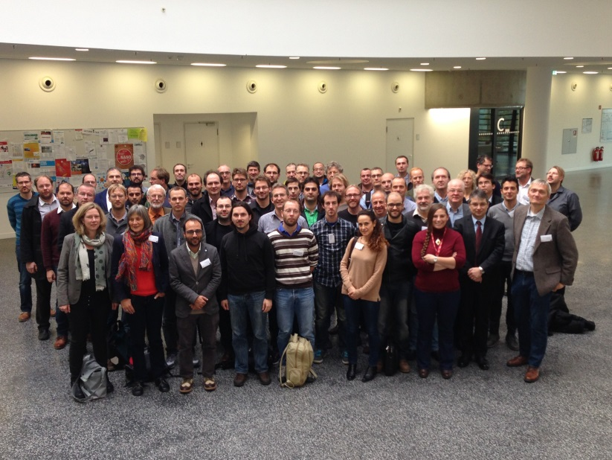

Figure 1: EUCALL Project Partners at the kick-off meeting.

The EUCALL kick-off meeting took place in Hamburg during 29-30.10.2015 and was hosted by European XFEL/DESY. The program was created under the supervision of the Coordinator, who also compiled the report about the kick-off meeting (Deliverable 1.1). The 1st EUCALL Annual Meeting was held at HZDR during 31.08-02.09.2016. The program was created by the local organizer in collaboration with the Coordinator, and discussed, reviewed and ratified by the EB and SC members. The Coordinator composed the report of the 1st EUCALL Annual Meeting (Deliverable 1.2).

The date and location of the 2nd EUCALL Annual Meeting (07-09.06.2017 at ESRF) is already defined, as well as the Meeting Program. The program was created by the local organizer in collaboration with the Coordinator, and ratified by the EB and SC members. Furthermore it has already been confirmed that the 3rd EUCALL Annual Meeting will be held during summer 2018 at ELI-Beamlines (Czech Republic).

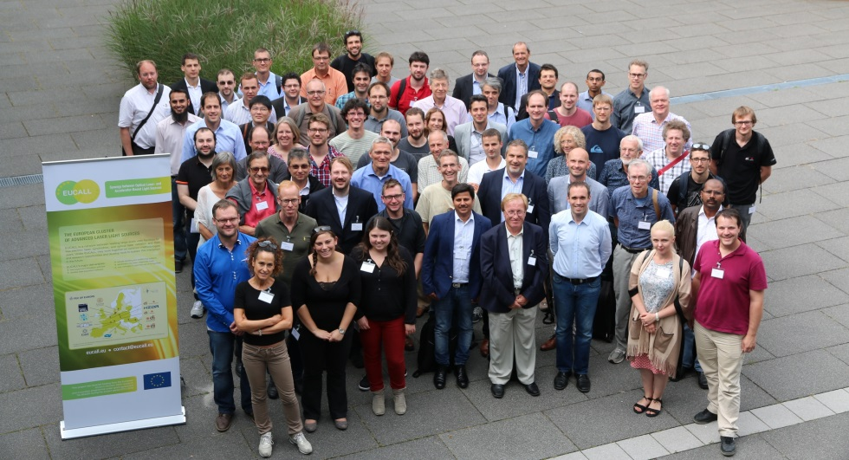

Figure 2: Project Partners at the 1st EUCALL Annual Meeting.

The EUCALL SAC Meeting 2016 was held at European XFEL during 21-22.09.2016, and the program of the meeting was organized by the Coordinator and the SAC chair. Organization of accommodation and the reimbursement of travel costs for the SAC Members were supported by the Coordinator. The SAC Report (attached as Annex 1) was delivered to the Coordinator by the SAC Chair, and was distributed to the SC and EB. The Coordinator organized meetings with the WPLs of each WP to discuss topics from the SAC report which needed to be addressed, and a response to the SAC was developed by the Coordinator. This response has been approved by the SC and EB and delivered to the SAC (attached as Annex 2). The EUCALL SAC Meeting 2017 has been scheduled for 09.06.2017 at ESRF as a satellite of the 2nd EUCALL Annual Meeting.

The following EB meetings have been held during the first reporting period as telephone calls hosted by European XFEL:

15.12.2015

03.04.2016

02.09.2016 (Joint meeting of EB with Synergy Board at 1st EUCALL Annual Meeting, HZDR)

12.12.2016

The next EB meeting is scheduled for 08.04.2017.

The following SC meetings have been held, including one which took place before the beginning of the first reporting period:

22.09.2015 (via TelCon)

31.10.2015 – at the kick-off meeting

14.03.2016 (via TelCon)

01.09.2016 – at the 1st Annual Meeting

18.01.2017 (via TelCon)

The next SC meeting is scheduled for 07.06.2017 – at the 2nd Annual Meeting.

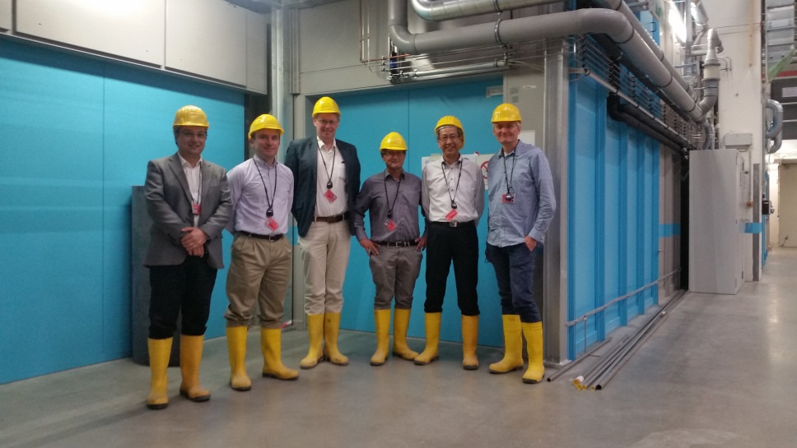

Figure 3: Members of the EUCALL SAC with EUCALL WPL/WPCs visiting the European XFEL experimental hall (at this time under construction) during the SAC Meeting 2016.

**Task 1.4: Management of project monitoring and reporting**

The Coordinator maintains status updates of the project progress via close interaction of the WP members responsible for the work, as well as monitoring progress towards the completion of upcoming Milestones and Deliverables. WP members are reminded two months in advance of any upcoming WP Milestones and Deliverables. The Coordinator collects and reviews the final version of each Milestone and Deliverables and uploads them to the EC project participant portal.

The Coordinator has collected the financial reports from each project beneficiary, and the technical reports from the WP members. The Coordinator has also created the draft and final version of the first periodic report (01.10.2015-31.03.2017).

**Task 1.5: Financial and legal coordination of the project**

The Coordinator organized the financial distribution of the prefinancing, advised the partners on financial issues as required, and made contact with the project officer in case of special questions or the need for budgetary changes. At the EUCALL kick-off meeting, the Coordinator informed the partners of the main EC regulations concerning the legal and budget issues, eligibility of costs and acknowledgment of financial support and open access requirements for publications.

A Consortium Agreement based on the DESCA-model was agreed between all partners. It established the governing bodies of EUCALL and regulates the interaction between the parties. In addition it complements the Grant Agreement with respect to rules on dissemination, use and access rights.

Following the 1st EUCALL Annual Meeting and its Satellite Workshop, the Coordinator received the request of two external research facilities to join the cluster as associate partners. The ascension of both Laboratoire pour l'Utilisation des Lasers Intense (LULI), France and Forschungszentrum Jülich (FZJ), Germany was approved by the SC and the legal contracts have been generated and signed. Following a final SC decision, the ascension of EUCALL’s two associate partners was completed on 14.04.2017 (in the second reporting period). These RIs will nominate staff to participate in EUCALL’s WPs and will be invited to participate in EUCALL’s project meetings, but will not receive financial support.

# 1.2.2 Work Package 2 - Dissemination and Outreach

**Task 2.1: Dissemination and Outreach**

WP2 has created the “identity package” for EUCALL, including the EUCALL logo, the templates for posters and PowerPoint presentations, and document templates (Deliverable 2.2). The instructions for use of documents have been distributed to all EUCALL project partners and the documents are available on the EUCALL internal website document library. Standard posters about EUCALL and standard PowerPoint slides describing the project have also been created and distributed to all EUCALL project partners.

The project website [www.eucall.eu](http://www.eucall.eu) was launched (Milestone 2.1) and is regularly updated with project news on its front page. Since the website launch, 21 project news articles have been published during the reporting period.

Accounts on Social Media have also been created by WP2, and all of the above mentioned news articles are shared on these accounts, as well as news articles from RI websites which combine laser and x-ray science. Social Media channels are considered to be a most effective method in addressing and engaging young people, here in particular young scientists:

[www.twitter.com/EUCALL_eu](http://www.twitter.com/EUCALL_eu) (100 followers, 313 tweets)

www.facebook.com/eucall (120 followers)

[www.linkedin.com/groups/8479169](https://www.linkedin.com/groups/8479169) (92 members)

A brochure explaining EUCALL aimed at the general, scientifically interested public was composed by the Coordinator, with significant input from EUCALL SC members, from FELs of Europe, from Laserlab-Europe, from the SC’s User Representatives, and finally from the PR group of European XFEL. 3000 copies of the brochure were printed, and during the first reporting period, approximately 2000 of these brochures were distributed to partner facilities and included as handout material at various scientific events. A EUCALL roll-up banner, seen in Figure 2, was produced. The roll-up banner and the brochure were confirmed by the SC to comprise EUCALL’s dissemination material (Milestone 2.2).

New “case study” flyers about WPs 3,4,6,7 have been prepared for use as hand-outs at scientific conferences and exhibitions. An “Open Letter” to policy makers describing EUCALL’s activities is also under development and will be distributed during the second reporting period.

WP2 has organized EUCALL’s participation in three exhibitions which will take place during 2017: SPIE Optics + Optoelectronics 2017 (Prague, Czech Republic), EuroNanoForum 2017 (Valetta, Malta) and LASER World of PHOTONICS 2017 (Munich, Germany). These conferences were selected since they gather large numbers of scientific staff and directors of accelerator and laser RIs, general scientists (in particular users of ALL-RIs), the industry, and policy makers. At these events, WP2 will distribute EUCALL’s own dissemination materials, as well as each partner facility’s own dissemination material about industrial access and cooperation to scientists, industrialists and policy makers.

During the first reporting period, WP2 has disseminated EUCALL’s objectives, goals and progress at 19 conferences, workshops, summer schools and other events, with oral and poster presentations, and distribution of brochures. Furthermore, presentations at photon science RIs have been held to promote EUCALL to scientific staff not directly involved with EUCALL. These activities, as well as those dissemination activities performed by other WPs are shown in Annex 3. WP2 has also published 19 articles in the consortium members’ regular newsletters, on general physics news platforms and in EC channels.

The above activities which provide dissemination material about EUCALL partners and activities to the beneficiaries, peers and the public satisfy Deliverable 2.3.

WP2 has organized and provided Young Researcher Travel Bursaries of up to 500€ each (to current or recent PhD students), supporting travel, accommodation and registration costs to the following summer schools, conferences and workshops, arranged or supported by consortium members:

* ELI Summer School 2016 (ELI) – 9 Travel Bursaries provided
* Science@FELs Conference 2016 (Elettra) – 20 Travel Bursaries provided
* Workshop: Studies of Dynamically Compressed Matter with X-rays (ESRF) – 10 Travel Bursaries provided

It was decided by the EUCALL SC to offer Young Researcher Travel Bursaries to the ELI Summer School 2017 and for the Spring School on Synchrotron and FEL methods for Multidisciplinary Applications 2018. Travel Bursaries to the International Conference on Extreme Light 2017 (ELI) and the 4th International Conference on Ultrafast Structural Dynamics 2017 (Elettra) were proposed, but a SC decision on these was only possible in the second reporting period (approved on 15.04.2017).

**Task 2.2: Promotion of communication activities**

WP2 established a user communication platform based on the recommendations of WP3 members, the SB and approved by the SC (Milestone 2.3). A website was developed ([www.eucall.eu/outreach](http://www.eucall.eu/outreach)) which contains links and subscription information for newsletters of each EUCALL beneficiary, websites for the events organized by each member and for all of the social media accounts of the facilities. The existence of this communication platform was disseminated by many EUCALL partner RIs, such as in newsletters and announcements from ELI, European XFEL, FELs of Europe, and Laserlab-Europe.

WP2 supported the organization of workshops within WP3/WP6 (Building a Target Network for Advanced Laser Light Sources, 29-31.08.2016) and WP5 (EUCALL GPU/FPGA Workshop, 15-18.11.2016). WP2 is supporting WP3’s upcoming workshops on experience exchange and Joint Foresight topics, planned for the second reporting period.

# 1.2.3 Work Package 3 – Synergy of Advanced Light Sources

**Task 3.1: Installation of a Synergy Board (ELI)**

The Synergy Board (SB) was formed out of several WP3 members, and two external members representing the OL community and the FEL community (Milestone 3.1). The composition of the SB is given in Table 4. WP3 members nominated several external scientists to represent the SR community, however none of those nominated were available to join the SB. Due to the WPL and WPC’s extensive expertise in synchrotron radiation, it was decided that initially two external SB members would be included during the first project period, and a decision to possibly expand the SB to up to five external members would be made in 2017. The SB Terms of Reference (Deliverable D3.1) were developed by WP3 members at ELI and European XFEL and agreed upon with members from FELs of Europe/DESY and Laserlab-Europe/LU. European XFEL organizes telephone conferences every 1-3 months for the SB to discuss WP3’s activities and progress.

|  |  |  |
| --- | --- | --- |
| **Name** | **Affiliation** | **Represents** |
| **Catalin Miron (SB Chair)** | ELI-DC | OL and SR facilities |
| **Thomas Tschentscher** | European XFEL | FEL and SR facilities |
| **Ute Krell** | DESY | SR facilities |
| **Daniela Stozno** | Lund University | OL facilities |
| **Josef Feldhaus** | DESY | FEL and SR facilities |
| **Didier Normand** | French Alternative Energies and Atomic Energy Commission | OL facilities |

Table 4: Composition of the EUCALL Synergy Board.

**Task 3.2: Analyse and promote possible synergies in science and innovation (all)**

The super-matrix of “Instrumentation at ALL-RIs” was initiated by WP3 members at European XFEL and expanded and refined with input from members at ELI, FELs of Europe/DESY, Laserlab-Europe/LU as well as HZDR, ESRF and the SAC. WP3 members entered the information into the super-matrix, gathered primarily from the websites of the facilities. The facilities examined were EUCALL’s consortium members, as well as several international facilities. From the selected RIs, only beamlines or instruments were examined which satisfy the following selection criteria, most relevant to EUCALL:

* User access is offered to intense beams of short wavelength (UV or x-ray) photons
* At the instrument, UV or x-ray photons are combined with laser instrumentation or have laser-like characteristics. This can include:
  + Pump-probe experiments with optical lasers
  + Instrumentation for dynamic compression with optical lasers
  + UV or x-ray photon beams with a high coherence factor
  + UV or x-ray photon beams with femtosecond pulse duration

A primary analysis of the results was created by European XFEL, ELI, FELs of Europe/DESY and Laserlab-Europe/LU and the results were delivered to the WP3 members and the SB for further analysis in fulfillment of Milestone 3.3. A timeframe was defined for the SB to provide their primary observations and conclusions to the WPL during May 2017. WP3 members at ELI and European XFEL will prepare the initial results for discussion during the 2nd EUCALL Annual Meeting. The results of this analysis will contribute to the WP3 Deliverable D3.2 “Synergy and Innovation Potential of EUCALL” (due March 2018).

The initial results of the super-matrix data collection indicate that the expected photon beamline characteristics for each pillar of the currently under-construction facility ELI are not clearly or completely shown on the facility websites. Discussion of this point within WP3 lead to recognition that ELI has also not yet defined and approved access policies and support methodologies for its future users. WP3 members identified the need for an experience exchange workshop, during which the operators of each user facility exchange information about their standard practices – this will be particularly interesting for those under construction RIs who can define their user access policies based on practices at currently operational facilities such as DESY or ESRF. The proposed content for this workshop has been generated by members of ELI’s future User Offices, and developed by WP3 members – this includes topics such as “Calls for Proposals”, “User Portal”, “Safety Training of Users, and Safety Staff”, “Publication Database” and “Joint Access Policies”. This workshop will be held at ELI Beamlines during late 2017.

EUCALL’s SAC recommended the further development of the super-matrix. A new goal for WP3 is therefore to develop the data in the super-matrix into a searchable database, which could be used by scientists (for example users and RI operators) to locate suitable beamlines/instruments for their given experimental requirements. A similar database for synchrotron and FEL facilities is operated by Elettra at the website [www.wayforlight.eu](http://www.wayforlight.eu). WP3 members have initiated collaboration with the developers of the wayforlight database, and would develop a prototype search database for EUCALL’s data-collection implementation into the wayforlight database. The wayforlight database could thus be extended to include the ELI facilities and the relevant Laserlab-Europe instruments. A boundary condition is that such a database should remain up to date and be implemented in a sustainable fashion. A concept would be developed which allows beamline operators to enter their beamline’s information into a single data entry platform, which would update all relevant websites together (for example at both the RI’s own website as well as the EUCALL WP3 database). A prototype database (for example for just the EUCALL consortium members) would be presented to the facility operators to show how such an updatable database could be maintained in the future.

Regarding innovation at RIs, a survey consisting of questions about “Joint development of technology with industry”, “Support of spin-off companies” and “Industrial access to ALL-RIs” was created by WP3 members at European XFEL and developed/refined by WP3 members from ELI, FELs of Europe/DESY, Laserlab-Europe/LU, HZDR and ESRF. European XFEL and ELI conducted interviews with Technology Transfer representatives of all EUCALL consortium members as well as several external facilities: Soleil (France), Spring-8 (Japan), Diamond Light Source (UK), Brookhaven National Lab (USA). A primary analysis of the results was created by WP3 members at European XFEL, ELI, FELs of Europe/DESY, Laserlab-Europe/LU and the results were delivered to the WP3 members and SB for further analysis. WP3 and SB members will provide their initial feedback for each of these reports during May 2017 for discussion at the 2nd EUCALL Annual Meeting. The results of this analysis will also contribute to the WP3 Deliverable D3.2 “Synergy and Innovation Potential of EUCALL”.

This “Innovation Potential” data collection has shown that the under-construction facilities ELI, European XFEL and MAX IV (as part of Lund University) have not yet fully defined their policies for Technology Transfer. To address this issue, WP3 members are organizing an experience exchange workshop, at which these policies can be further discussed between the facilities’ Technology Transfer offices. In particular, it is expected that the newer facilities ELI, European XFEL and MAX IV/LU have the opportunity to establish and/or review their policies based on the “best practices” at operational facilities such as Diamond Light Source, PSI and Elettra-Sincrotrone Trieste. This workshop will be held at one of the EUCALL RIs during early 2018.

Furthermore, WP3 members are organizing a workshop entitled “Biology at Advanced Laser Light Sources” to provide scientific experience exchange between synchrotron, FEL and OL communities, for RI operators, users and the industry. The focus on biology applications was selected since these are currently of very high relevance to all of the participating ALL-RIs. The workshop shall allow understanding of what the synergies between the different sub-groups are, as well as how to identify and develop them and later to extend these synergies into other communities. The workshop will cover applications and techniques of Biological Imaging, Crystallography and Serial Crystallography, and Structural Dynamics in biological matter in general. Presentation of the capabilities of each type of RI will contribute to an exchange of best user experience. Extra sessions on Industrial Needs and Applications, and new requirements from the Biology Community will expand the themes to cover innovation and joint foresight topics. This workshop will be held at European XFEL during Q4 2017, and local organizers and Program Advisory Committee have already been defined.

The workshops described above were approved by the EUCALL SC as EUCALL’s programme for WP3 exchange and experience for RI staff and users (Milestone 3.2).

**Task 3.3 Develop, promote, and implement strategies towards optimum combined use of advanced laser light sources (all)**

WP3 members from ELI developed a survey for the project leaders of the following cross-community projects:

* HIBEF (The Helmholtz International Beamline for Extreme Fields at the European XFEL)
* Lasers at ESRF
* Table-top FELs at DESY and ELI

The questions were developed/refined by WP3 members from European XFEL, FELs of Europe/DESY and Laserlab-Europe/LU. Interviews were conducted by ELI, with support from European XFEL. A primary analysis of the results was created by WP3 members at European XFEL, ELI, FELs of Europe/DESY and Laserlab-Europe/LU and the results were delivered to the WP3 members and SB for further analysis. The results of this analysis will also contribute to the WP3 Deliverable D3.2 “Synergy and Innovation Potential of EUCALL”.

**Task 3.4 Identify joint foresight topics (all)**

Joint foresight topics were identified and have been developed between all WP3 partners and presented to the SB, SC, EB and SAC. The SAC was especially active in recommending further development of the joint foresight topics. Each topic consists of setting up a vision for a future activity of the ALL-RI communities, parts thereof or new alliances among the ALL-RI communities with new outside communities. This process will lead to a draft concept document, outlining why such an activity is needed, how it is motivated, and how it might be responded to by the respective communities. In a first step the framework for the Foresight Workshops will be defined, at which invited and contributed presentations on topics with high relevance to the respective workshop theme from within and outside EUCALL shall elaborate the requirement case (state-of-the-art, current and future needs). As an outcome a concept document for each foresight topic will be produced and disseminated (final deliverable). These activities are considered as seeds for future cooperation and collaborations.

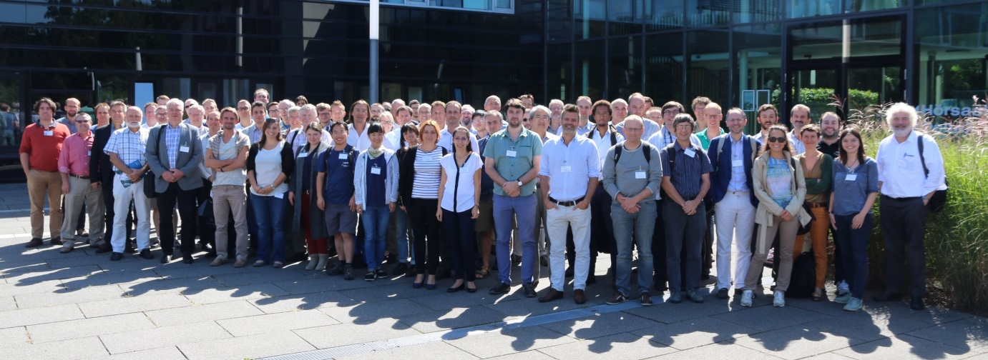

Figure 4: Participants of the “Building a Target Supply Network for Advanced Laser Light Sources” at HZDR.

A. Building a Target Supply Network for Advanced Laser Light Sources

The interest in this activity arises from the recognition that the high-repetition-rate laser experiments, which will soon become possible at facilities such as ELI, ESRF, European XFEL, and ESRF, as well as at other ALL-RIs, will require targets (or samples) in the quantity of few 1000 up to as high as few 100000 per year. This leads to the requirement of target production facilities capable of producing a range of complicated targets in large number with the needed high-precision. While in the USA and Asia certain support networks for targets supply exist, the European community has no coordinated strategy to access target fabrication infrastructure. A possible solution could be a consortium of European ALL-RIs, target suppliers and specialized laboratories. This issue/need has been addressed in a first workshop held in August 2016 at HZDR as a satellite to the EUCALL 1st Annual Meeting, in collaboration with members of WP6. Following up on this workshop a report has been written and was published, and all information can be found at [www.eucall.eu/target_network](http://www.eucall.eu/target_network). The outline of a White Book was produced and the wider community of ALL-RI facilities has been informed about this activity (DESY, ELI, European XFEL, ESRF, HZDR, and a number of facilities within the Laserlab-Europe network). A meeting of facility managements was initiated in order to determine the needs of the various ALL-RIs and the level of support to such an activity. This meeting shall as well determine the most important use scenarios and thereby refine the main directions. Developing these in the White Book, investigating schemes for collaboration and funding, and preparing a final Foresight Workshop, where the concept is presented to the wider community, are main activities under this topic.

A meeting of facility directors of the above mentioned RIs was held on 10 April 2017 (in the second reporting period) to define timeline and scope of this activity, and a second workshop is envisioned for early 2018.

B. High Impact Science at Advanced Laser Light Sources

Originally conceived to discuss and disseminate experiments and methods making best use of the combined properties of laser and x-ray sources (new opportunities enabled uniquely by ALL-RIs), it was suggested by the SAC that the scope should enlarge to address most urgent scientific and societal challenges and how ALL-RIs could contribute to solving these. First suggestions for such topics are artificial photo-synthesis, light-induced phase-transitions or carbon capture and storage. Several directions can be combined in one program. To give the according foresight workshop a coherent scope, a program committee shall predefine specific development areas or scientific applications which make particular good use of the combined properties of ALL-RIs as the focus areas for the workshop. Other contributions will be added through contributed talks or posters.

The workshop is planned for early 2018, at one of the EUCALL RIs.

C. Theory/simulation/computing and related data handling

There is a recognized need for theory development to accompany experiments at ALL-RIs and interpretation of results. This area could span an enormous range, for example from light-matter interaction, over FEL theory to complex time-dependent theories describing transition states. Furthermore, there is a need for advanced simulations to accompany (predict and explain) experiment results. Finally, computing issues (both hardware & software) were raised in response to the upcoming challenges to deal with very large quantities of data and needing high performance computing for complex calculations or simulations. The organization committee is in place, and the first activity shall define a coherent concept of a Foresight Workshop responding to this topic.

The workshop is planned for early 2018, at one of the EUCALL RIs.

D. Future strategies for RI Operators and Policy Makers

The main purpose of this activity is the dissemination of EUCALL synergy results to its stake-holders and policy makers. A focus of this workshop will be the presentation/discussion of strategies, operation needs, and possible frameworks for future collaborations between ALL-RIs.

This meeting will be held in 2018 either in Brussels or alternatively in conjunction with the 3rd EUCALL Annual Meeting at ELI-Beamlines (Czech Republic).

# 1.2.4 Work Package 4 – Simulation of Experiments (SIMEX)

The new simulation platform for photon science experiments “simex_platform” has been established to completely simulate photon science experiments performed at ALL-RIs. An outline of the baseline workflow for the simulation is shown in Figure 5. EUCALL has collected individual simulation modules and written scriptable python user interfaces (hereafter referred to as “*Calculators*”) for each part of the workflow chain, for example the photon source or the photon-matter interaction, and developed data interfaces such that the output of one simulation module is used as the input to the next.

The open source software repository “eucall-software” was created and all software developed as part of the simex_platform can be downloaded here. This repository now also hosts software developed in other EUCALL WPs. This is found at [www.github.com/eucall-software](http://www.github.com/eucall-software).

**Task 4.1.1: X-ray optics and beam propagation (XFEL, ESRF)**

At European XFEL, the simulation module for x-ray optics and propagation of coherent x-ray pulses in x-ray FEL beamlines was completed. It utilizes "WavePropaGator" (WPG), a python interface library to the state-of-the-art wavefront propagation code "Synchrotron Radiation Workshop" (SRW). SIMEX provides a *Calculator* to the WPG library utilities and predefined WPG beamline definitions for the SPB-SFX instrument at the European XFEL. Further beamlines for European XFEL or other FEL facilities can easily be added if needed.

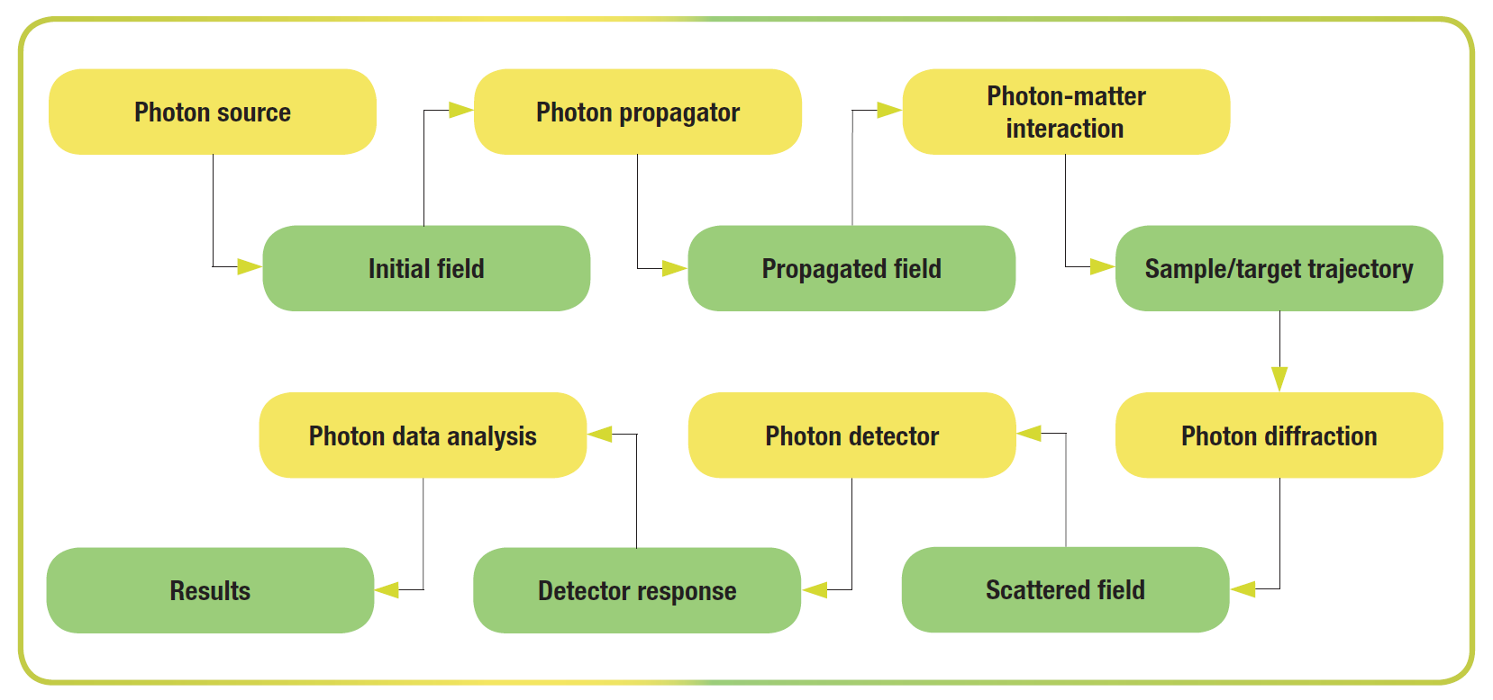

Figure 5: Baseline workflow in simex_platform. Yellow boxes represent “*Calculator*” user interfaces, green boxes are data interfaces.

WPG has the capability to read in precomputed x-ray pulse data from the XFEL pulse database (XPD). Propagated wavefronts are stored in the same format at XPD entries, facilitating the data transfer. In order to provide a more generic data interface, WPG output can optionally be reformatted to comply with the “openPMD” metadata standard used, for example by the particle-in-cell code “PIConGPU”. The latter is used for short pulsed optical laser-matter interaction in SIMEX and other codes.

The simulation module for x-ray optics and beam propagation for the ESRF is realized using the Orange Synchrotron Suite (OASYS) software which is an open source graphical user interface (GUI). OASYS includes “ShadowOui”, which is the OASYS interface for ray tracing open source software.

The workflow consists of graphical modules that can be inserted onto the workspace; which represents the synchrotron beamline and all its optics. At ESRF, a workspace has been developed to simulate the ID24 beamline (x-ray absorption studies) where the first dynamic compression experiments (long pulse laser-matter interactions) will be carried out. Graphs can be generated within the OASYS software to display x-ray properties at any point in the workflow. Once the entire beamline optics have been simulated (and the x-ray source has been chosen), all the relevant information from the simulation can be passed to other SIMEX platforms by running a python script directly in OASYS.

The python script initiates the photon-matter interaction *Calculator* (Task 4.1.2.), passing it the relevant information to determine the required target parameters before running the hydrocode simulations with expected laser conditions. Further code has been developed to enable semi-automated pulse profile optimization in an iterative procedure based on simulated target parameters.

**Task 4.1.2: Sample-photon interaction (XFEL, HZDR, ESRF, ELI)**

The code suite “XRAYPAC” was employed at European XFEL to model the interaction of coherent ultra-intense x-ray pulses with atomic and molecular samples, e.g. biomolecules for coherent imaging applications (single particle imaging). The code is developed and maintained at the Center for Free Electron Laser Science (CFEL) at DESY.

XRAYPAC reads the output of the wavefront propagation module and a file that contains the initial atomic structure of the sample (atomic species and Cartesian coordinates of each atom.) It calculates the atomic structure and the electron density distribution as a function of time taking into account the interaction with the external FEL field. This data is stored at defined intervals ("snapshots").

Execution of XRAYPAC requires a license. The licensing process took longer than anticipated, which has delayed its integration into SIMEX. A demo version of XRAYPAC can be run through SIMEX, using the same data formats for input and output. An interface to the full version of XRAYPAC will be developed at European XFEL as soon as the code becomes available. In the meantime, data from the wavefront propagation must be sent via network to the XRAYPAC developers at CFEL. XRAYPAC results are then sent back to the SIMEX user for further processing (scattering calculations).

The interaction of ultrashort ultraintense lasers with solid matter is simulated at HZDR using the open source code “PIConGPU”. It solves Maxwell’s equations on a grid with ions and electrons treated as clouds of charged particles. PIConGPU is under constant development with regular releases and now also features first methods to extend its applicability towards solid-density targets. For interaction with other modules of SIMEX, HZDR implemented standardized input and output in openPMD format. The output can therefore serve as input for FEL simulations or for scattering simulations such as HZDR’s in-house “ParaTAXIS” project. HZDR has also implemented photon transport and interaction with the sample through atomic physics by generalizing the particle model to carry additional information about the states of the particles within the particle cloud it resembles, for example electronic level populations.

At ESRF, laser-matter interactions are modelled with 1D radiation hydrodynamics computer codes. ESRF employed the code “Esther”, developed by the CEA France, to model the interaction between long-pulse high energy lasers and sample target packages. The license to use Esther must be obtained by requesting (via email) academic use of the program from the authors. To integrate the modelling requirement of SIMEX to pass between two subsequent *Calculators*, ESRF has developed interface modules to interact with Esther. The main module creates the input file required to run the hydrocode. This takes both the requested parameters from the user (target sample and laser properties) as well as any information passed from the x-ray tracing simulations.

At ELI, it is possible to amplify low intensity ultra-short (sub-femtosecond) pulses using an intermediate amplifying medium by using resonant backward Raman amplification (BRA). Such pulses are anticipated at the secondary photon sources at ELI-ALPS (Attosecond Light Pulse Source). In preliminary assessment of the scheme, the analytical expressions for the pump/seed laser pulses and characteristic features are obtained which concisely describe the parameter regime of resonant BRA applicability in achieving significant amplification. The consistency of the scheme in the context of ELI-ALPS sources has been validated through particle in cell simulations. The peak intensity of the amplified seed pulse predicted via simulation results is found to be in reasonable agreement with the analytical estimates. Utilizing these analytical expressions as a basis in perspective of ELI-ALPS parameter access, a specific example displaying the key and laser parameters for amplifying weak

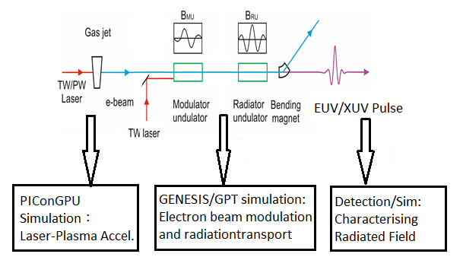

Figure 6: A *Calculator* which defines the PIC simulation output to the FEL simulation code as an input electron beam.

seed pulse has been configured; the limitations and conceivable remedies in resonant BRA implementation have also been highlighted.

Resulting from the collaborations to date, a new goal for the SIMEX work package has been defined. The ‘laser plasma accelerator based coherent light source’ is a near future challenge for several large-scale accelerator facilities such as LBNL (USA) and RAL (UK) and recent research collaborations such as EuPRAXIA; who look to the future in substituting the ‘large and high cost’ conventional accelerator with ‘compact and economic’ ‘laser plasma accelerator’ (LPA). Since the conventional accelerator has an electric field gradient limit due to the structure surface field limit, the best gradient achieved now is less than 100 MeV/m. LPAs could be the next generation accelerator facilities with ultrahigh gradients reaching 100 GeV/m – this could greatly miniaturize accelerator facilities.

It is proposed to extend the development of SIMEX platform in order to investigate the simulation of LPA based coherent light sources. This will be done by feeding the output of the PIC simulation, i.e. the phase space distribution of accelerated electrons into a FEL simulation code to investigate the possibility of laser based FELs with realistic electron bunch properties. Development of SIMEX into this technology will allow us to investigate the suitability of laser plasma accelerators as a source of high quality electron beams rather than linear accelerators.

This simulation development was initially discussed during the 1st EUCALL Annual Meeting. SIMEX members at ELI and European XFEL initiated the project from 13.02.2017. The main task in this project is to enable the simulation of LPA based coherent light sources (FELs) by coupling a particle-in-cell (PIC) code that describes the LPA to a FEL simulation code (GENESIS). During February 2017, a python calculator was developed which combines the PIC simulation output (using PIConGPU code) to the FEL simulation code as an input electron beam, as shown in Figure 6.

Thereafter the electron beam data generated from the LPA simulation was readable to the FEL simulation code GENESIS, to study it further a source of coherent radiation. The current form of simulation software needs further advancement to enable the optimization of focusing optics, magnetic chicane, magnetic undulator and radiation undulator; to minimize the input data during the execution of SIMEX.

**Task 4.1.3: Scattering signal simulation (XFEL, ELI)**

Two scattering codes are developed and maintained by European XFEL: "singFEL" for scattering from finite systems (atoms, molecules, clusters), and "XRTS" for scattering from plasmas. Both have been fully integrated into SIMEX, allowing to setup and execute simulations using a generic scriptable user interface. The data format has been designed such that both applications can read the results from the beamline propagation.

singFEL reads the snapshots from the photon-matter interaction calculation, the scattering geometry (detector position, size, and pixels), and the intensity distribution in the sample interaction plane resulting from the beamline propagation. From this input data, it computes the scattered intensity in each detector pixel as a function of time and the integrated signal. This serves as input for a detector simulation.

XRTS calculates a scattering spectrum for given plasma parameters (density and temperature) and scattering geometry. The source spectrum and the detector point spread function are convoluted with the scattering spectrum. In a next step, integration over density- and temperature-profiles, taken for example from optical laser-plasma interaction calculations, will be added as a feature to SIMEX.

In deviation from the description of activities, the simulations of scattering from short-pulse laser produced plasmas, as simulated by particle-in-cell code (PIC), will be implemented and performed by HZDR, rather than by ELI.

HZDR developed a scattering code “ParaTAXIS” running on GPUs that adds the capability to SIMEX to simulate x-ray photon scattering in short-pulse laser generated plasmas. It takes input from SIMEX's x-ray generation and propagation in openPMD format and converts the x-ray wavefronts to photons in a particle interpretation. It is hence fully integrated in the SIMEX platform. The photons are then traced through the plasma (plasma data read from an offline PIC simulation) and are scattered on electron and ion density and propagated further. The correct phase relation of the photons is kept to allow for coherent superposition later at the detector. Development is ongoing in order to implement more scattering channels in a next step.

**Task 4.1.4: Detection (all)**

Simulation of the detector response to incoming scattered radiation is handled in two qualitatively different ways at European XFEL:

1) Poissonization only: The calculated distribution of scattered intensity in the detector plane is converted into a distribution of scattered photons per detector pixel. To mimic the Poissonian counting statistics of pixel detectors, this photon distribution is convolved with a Poisson distribution at each pixel.

2) Detailed detector simulation: The x-ray camera simulation toolkit “X-CSIT” allows detailed detector simulations including particle creation, charge transport, and electronics of real detectors. Integration of X-CSIT into SIMEX is complicated by the dependency of the extensions on Karabo, the European XFEL data handling and controls framework. Both Karabo and X-CSIT are under heavy development. Only very recently, X-CSIT has been updated to comply with the latest release of Karabo, such that it could now also be integrated into SIMEX. Already now, it is possible to feed singFEL data into a standalone version of X-CSIT (i.e. independent of SIMEX) and hand the resulting data back to the SIMEX toolchain thanks to already defined data interfaces.

For x-ray absorption (XAS) experiments at the ESRF, one of the critical components of the target package is the sample thickness for the particular k-edge of the sample being studied. This determines the XAS jump and has a large impact on data quality. One aspect of the hydrocode simulations from ESRF is to perform a loop function to optimize the sample thickness based on the expected flux (from x-ray source simulations) and the minimum/maximum sample thickness based on the hydrocode wave interactions. The XAS signal reflects the local order of the shock compressed matter and can be simulated by combining first principle electronic structure methods with linear response theory. A well-known implementation is the non-open source code “FEFF”.

To enhance and extract further relevant information from the hydrocode simulations, the particle velocity can be extracted from the resulting files to show the expected VISAR signal (velocimetry diagnostic traditionally used in long pulse shock experiments to determine pressure).

Detailed modelling of the x-ray detector for x-ray absorption spectroscopy, used at ESRF, is not foreseen. Absorption spectra simulated by FEFF will be convoluted with a detector point spread function and source bandwidth.

Detector modelling for ELI specific applications will re-use the tools and concepts developed at European XFEL, such that a separate detector modelling activity at ELI is not required. Instead, ELI (ALPS) will concentrate on the simulations of novel x-ray source concepts based on Laser-Wakefield Electron Acceleration described previously.

Milestone 4.1 demonstrated that all aforementioned simulation modules are operable. The Milestone document lists the definition of used data interfaces and provides details about the simulation codes.

**Task 4.2: Simulation from source to signal (all)**

As a first application of the SIMEX simulation platform, European XFEL performed a start-to-end simulation of a single-particle imaging experiment, using ultra-short 3 fs pulses of 5 keV FEL radiation focussed onto a 7 nm sized biomolecule (PDB entry 2NIP). The diffracted radiation is captured in a 2D pixel area detector. Results of this study have been submitted for publication.

The integrated radiation-hydrodynamics simulation capabilities were used at ESRF to optimize the drive laser pulse profile in a hypothetic dynamic compression experiment with iron targets, and model the (optical) photon-matter interaction. Documentation of this study will be provided to SIMEX users as an online tutorial. This is currently in preparation. The next step will be to couple the radiation-hydrodynamics simulations with a simulation of the x-ray probe (ESRF synchrotron), described by the x-ray raytracing method and simulations of the x-ray absorption fine structure signal using electronic structure calculations and the FEFF code.

At HZDR, work is ongoing to produce a synthetic diffraction pattern from hot and dense plasmas excited by a short-pulse optical laser and probed by coherent x-ray photons delivered from the European XFEL. The x-ray field is simulated by coherent wavefront propagation, while the optical photon-matter interaction is simulated by PIC codes. Diffraction (scattering) is described by the “paraTAXIS code”. All codes are part of the SIMEX repository.

**Task 4.3: Test and validate modules and workflow, including HPC workflow (DESY, all)**

Work at DESY has focussed predominantly on adapting the simulation codes used in SIMEX for use on High Performance Computing (HPC) platforms where this was not already the case. In particular, the code “SRW” for coherent wavefront propagation has been upgraded to benefit from shared-memory parallelism using the “OpenMP” framework. Secondly, a SRW version compiled with MPI allows processing of many x-ray source fields in parallel, which speeds up sampling of source fluctuations.

Running SIMEX on HPC platforms is facilitated by a mechanism in the python layer of simex_platform that identifies the HPC resources (number of CPU cores, number of nodes) semi-automatically and sets the batch execution parameters accordingly.

At European XFEL, the validity of single-particle imaging simulations have started to be assessed by benchmarking the SIMEX simulation results against experimental data collected at LCLS, Stanford, USA. Two diffraction datasets will be employed, one single-particle dataset from RDV Virus measured at the AMO end-station and one serial crystallography dataset from C60 nanocrystals measured during a beamtime in April 2016 (experiment LK88) in which two SIMEX members took part. This data will serve for validation of our simulation tools, in particular radiation damage (x-ray-matter interaction) and diffraction.

Work began at DESY to develop a web-based simulation platform as a service to users by exposing the simex_platform user interfaces through a web-based graphical user interface. European XFEL is currently consolidating common data analysis tasks in virtual diffraction experiments in an object-oriented programming approach. Similar to “*Calculators*”, “*Analyzers*” encapsulate data analysis tasks like image plotting, projections, integrations and statistical analysis. The open platform will allow and facilitate integration of established data analysis codes into SIMEX and usage of SIMEX simulations and analysis, for example in the European XFEL data analysis framework “Karabo”.

# 1.2.5 Work Package 5 – Ultrafast Data Acquisition (UFDAC)

**Task 5.1: Online 2D image processing (HZDR, DESY, XFEL, PSI, ELI (observer), ESRF**

**(observer))**

Significant data rates and sophisticated processing algorithms are required for online 2D image processing. Typical platforms are Field Programmable Gate Array (FPGA) and Graphical Processing Unit (GPU) technologies, besides ordinary Central Processing Unit (CPU) technologies. During joint discussions and individual interactions among EUCALL’s RIs it was recognized that it is not always clear which technology is the most suitable for particular applications and that experts with experience in both fields are extremely rare. Therefore European XFEL and HZDR organized a joint GPU/FPGA workshop (hosted at European XFEL) which aimed to: (1) provide an introduction into the key technologies, (2) train participants (who are mostly experienced in only one technology) into all technologies, and (3) include key-note presentations on data interfacing and processing frameworks.

The GPU/FPGA workshop was held in November 2016 and successfully covered the envisioned goals, produced a very positive resonance and strengthened the collaboration among the involved RIs (Figure 7).

HZDR has developed a first prototype for conversion of JUNGFRAU image detector data using GPUs together with PSI. HZDR also developed prototype implementations of more complex imaging algorithms for phase retrieval on multiple GPUs to test performance and scalability. For both Tasks 5.1 and 5.2 HZDR has written the Open Source library “ALPAKA” (available on Github) for abstracting many-core hardware programming (AMD & NVIDIA GPUs, Intel MIC, CPUs, ARM) and achieving performance portability. Optimization and transfer of PSI’s GPU solution to ELI is ongoing. The code will soon be released as open source on Github.

An algorithm to convert from dynamic gain switching charge integrating data into single photon counts has been developed at PSI for advanced integrating photon detectors such as JUNGFRAU, AGIPD and GOTTHARD. A GPU-based implementation of this algorithm for JUNGFRAU detectors has been carried out at HZDR and first offline tests show that this solution is able to process 1 GB of data in less than 30 ms per GPU. Results at HZDR also show that the maximum data transfer from the CPU to the GPU in their setup is 12 GB/s per GPU. This is demonstrated in Table 5.

Tests with online data in a dedicated setup at PSI have been planned and will be carried out in the short term. Additional algorithms for real time diagnostics and data reduction such as peak finding are foreseen to be developed for these detectors.

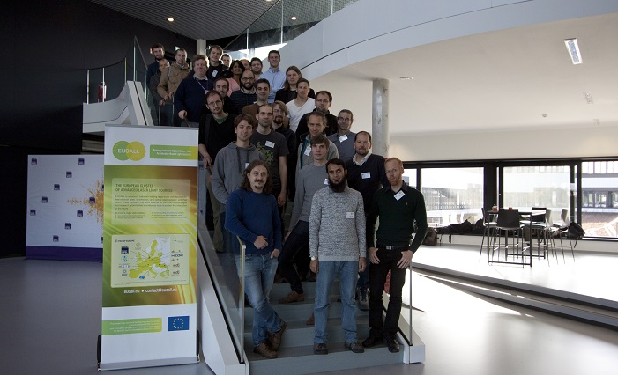

Figure 7: Participants of the GPU/FPGA workshop at European XFEL.



Table 5: Memory transfer rate (throughput) from host (CPU) to device (GPU). Except for the very first few images the throughput is always close to the maximum value achievable.

**Task 5.2: High-speed data transfer and data injection (ELI, XFEL, ESRF, HZDR, DESY (observer), PSI (observer))**

The aim of this task is to investigate the high speed data transfer from detectors into FPGAs and GPUs for online processing based on direct memory access (DMA). In the scope of this task, ELI performed a test-bench comparing the performance of GPU against CPU based solutions. This information allowed UFDAC to select specific cases where GPUs are a valuable alternative above classical CPU processing. A review of available standard Linux tools was performed concerning data-injection optimization. Examples are the tuning of multi-queue network cards and cache warm-up strategies. Furthermore, ELI’s collaboration with HZDR has started, in the framework of online data processing over a low latency Infiniband/Ethernet network focusing on “GPUDirect“ in order to achieve direct memory access between GPUs and between GPU and digitizer devices. For test benching, GPUDirect against standard TCP/IP and UDP communication was selected, since demonstration software is readably available and also due to the availability of NVIDIA hardware within the EUCALL collaboration. A performance evaluation of data transfer and injection algorithms is under preparation (Milestone 5.3). This may be complemented with the investigation of CPU-offloading towards FPGAs depending on the availability of hardware within the EUCALL collaboration.

“RASHPA” is a data acquisition framework for 2D x-ray detectors, and is one of two efforts within UFDAC looking into efficient data injection. It provides a solution for all partners, albeit with the restriction to PCIe. At ESRF, a new FPGA engineer was hired and trained in the use of the ESRF tools and the environment and concepts for RASHPA, which included studying the hardware and software codes developed within the CRISP (FP7) project. Several high speed data links that might be candidates for RASHPA implementation have been compared, and standalone IPs that are essentials for RASHPA implementation were tested. A development board from “Xilinx”, a new and advanced version of RASHPA, was redesigned, and the software library was updated for testing purposes.

A multi-link routed network topology with multiple data receivers using PCIe over cable as high speed data link was implemented, and more functions to the hardware were added, especially to the event signaling process. Updating the event channel allowed sending events to multiple data receivers. A PCIe routable RASHPA network was implemented.

One aspect of Task 5.2 is the investigation of current and upcoming interfacing technologies like 10/40G Ethernet and Ethernet-based zero-copy and DMA related data transfers. Besides individual studies, investigations and tests, this topic was also included in the EUCALL GPU/FPGA Workshop mentioned previously. Further studies and tests will be carried out at European XFEL during the remaining period of the EUCALL project.

For data transport, HZDR developed the open source communication abstraction library “Graybat” (available via Github) which allows the use of one communication stack for a variety of protocols (UDP, TCP/IP, MPI) and is currently interfaced to the “Cracen” project at HZDR. This allows for scalable and resilient connection of experimental DAQ to HPC systems and analysis terminals. Cracen is available as open source via Github. HZDR will evaluate how to integrate libraries such as RASHPA into Cracen.

At PSI, a JUNGFRAU module is producing 20 Gbit/s per module. Combining several of them to a full 16M detector increases the data rate to 80 GB/s. To handle this data rate one can either distribute the packets to different servers or increase the server CPU power and bandwidth. In collaboration with ESRF, PSI analyzed the situation and PSI will investigate FPGA based network card solutions. The idea is to develop a network card collecting and sorting the packets frame by frame doing a DMA copy transfer to the host memory afterwards. The so relieved host CPU is free to do further processing. Since modern FPGAs are equipped with dedicated PCIe 3.0 16x cores and 100 GB/s Ethernet cores, they are suitable for this task and of-the-shelf cards can be bought. Further investigations regarding Linux driver development and interrupt handling as well as measurements are planned.

**Task 5.3: Online processing of digitizer data (XFEL, ELI, ESRF (observer))**

The aim is to investigate and implement FPGA and GPU algorithms for online processing of data for feedback-based and real-time distributed control systems as well as online processing of digitized signals from diagnostics and detectors employed by users.

In this framework ELI is investigating the possibilities and the technological limits of an FPGA based image processing system. The main task is to acquire image data from a camera interfaced to FPGA hardware, carry out image processing on that data and provide resulted numerical or Boolean signals. The recent system is capable to provide Boolean signals based on the operations or calculations carried out on the image data such as interlock signals for upstream systems with a very low latency of 1.5 ms. However, this latency is limited by the speed of the image data transmission link and not by the FPGA. The FPGA is not only able to provide logic signals but also to acquire external ones such as trigger signals. The system is able to accept trigger signals from external sources and to use them to initiate image acquisition by routing it towards the camera. Functions above are required to make the system ready to be implemented into a real working environment. Current implementation is also capable to save digitized image data to memory that is interfaced to the FPGA and able to recall those images for either advanced processing or for offline analyzing. This system contains a real-time computer also that controls and monitors the acquisition as well as it can download the image data stored in the memory associated with the FPGA. The knowledge gained during this project can serve as a strong basis of several FPGA based image processing applications as it has delivered the fundamental knowledge about image acquisition and processing, input and output handling and also memory handling on FPGAs.

Significant progress was made at European XFEL related to FPGA based online processing of digitized data. The following most significant processing algorithms have been identified: zero suppression, energy detection, peak time detection, and signal filtering. Reference implementations and test for the first three have been done already. The algorithms were implemented in a generic and configurable way to be ported easily to different hardware. The reference implementation was tested on high-speed digitizers at a speed of 4 Giga-Samples per second. Further tests will be carried out and the remaining algorithm will be implemented during the next months.

HZDR has developed a GPU-parallel implementation of the Levenberg-Marquardt algorithm that has been evaluated for the Positron Annihilation Spectroscopy Experiment at HZDR but will be adapted to other applications within EUCALL. The software will be released as Open Source on Github.

Following the work done for Milestone 5.2, the general approach to progress these tasks is to integrate the various developments and share best practices, codes and solutions between EUCALL RIs. For this a common software repository on Github will be set up for sharing. With the identification of commonalities between applications in Milestone 5.1, the second phase of the UFDAC work package will drive the integration of these solutions wherever possible and feasible. This was addressed in detail during the GPU/FPGA workshop in November 2016.

UFDAC has become involved in providing data acquisition solutions for the hardware developed within WP7-PUCCA. A telephone conference was held between members of UDFAC and PUCCA on 23.02.2017 in order for PUCCA members to specify the data requirements of their devices and for UFDAC to determine where support can be provided. Currently HZDR is developing a plan to support PUCCA’s wavefront sensor with GPU firmware, while European XFEL is developing a procedure to support PUCCA’s gas x-ray intensity monitor detector with FPGA.

# 1.2.6 Work Package 6 – High Repetition Rate Sample Delivery (HIREP)

**Task 6.1: Automatic sample screening (ELI, XFEL, DESY)**

The work of HIREP started with discussing the demands of EUCALL’s RIs for high repetition rate fixed target delivery. Sample delivery is not limited to fixed targets in any of the participating facilities. Liquid and gaseous, as well as cryogenic samples also play an important role in high repetition rate sample delivery; these are independently developed at the different participating facilities. In fixed target sample delivery, however, HIREP found a common interest in unifying the sample environment project to facilitate easy exchange of samples between the facilities.

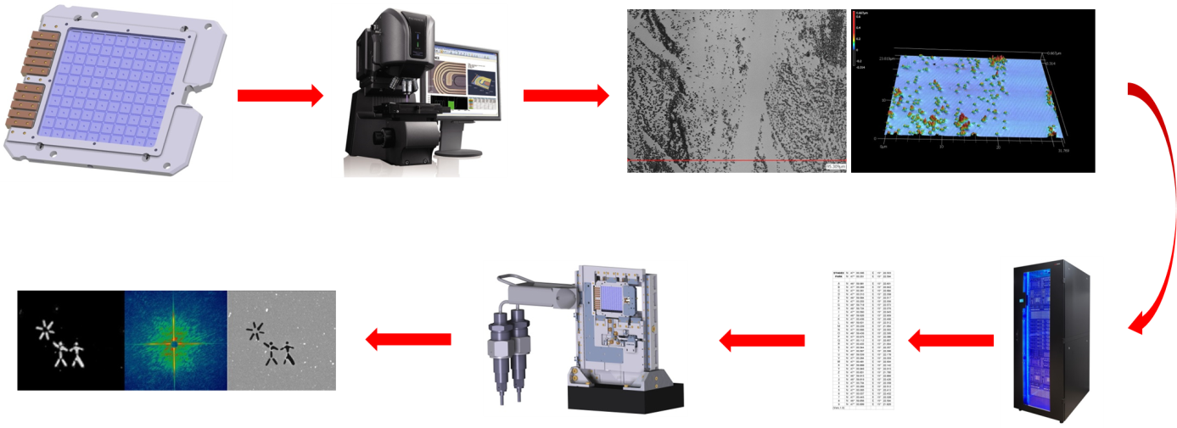

Figure 8: HIREP workflow. Users produce their own sample holder based on HIREP's designs. At the ALL-RI, the sample is automatically pre-characterized by a UHV microscope. The generated coordinates of the samples' points of interest are used to raster scan the sample at 10 -120 Hz through an x-ray or laser beam for various photon science experiments (x-ray diffraction demonstrated here).

The main interest of the beneficiaries lies in two distinct fields of research: High energy density experiments, where high power or high energy lasers are used for shock compression of matter or production of secondary radiation (i.e. ion beams), and coherent imaging and crystallography on biological samples.

While at first sight these scientific applications have not much in common, many challenges of high repetition rate sample delivery are common throughout the facilities and other facilities worldwide, especially based on the envisioned repetition rate. In preparation of Task 6.1 the specific requirements of each facility have been compiled. As a result, HIREP decided to work on two sample holders, rather than a single standard sample holder (Milestone 6.1). The workflow of HIREP’s planned system is illustrated in Figure 8.

For high repetition rate sample refreshment, as many samples need to fit on the target holder as possible. With a repetition rate of 10 – 120 Hz, thousands of targets can be scanned in just several minutes. As breaking the vacuum and replacing a sample holder can take close to one hour, large sample holders are a huge advantage.

Biological samples that easily dry out under vacuum conditions, on the other hand, need to be kept under cryogenic conditions while scanning. Cryo-cooling limits the size of the sample holders.

Therefore in Milestone 6.1, HIREP defined two separate sample holders: for high energy laser targets and dry samples for imaging under vacuum conditions, a sample holder with 110x100 mm active area and without cooling demands has been defined. For cryogenic samples, a chip-based sample holder with only 10x30 mm travel range has been foreseen.

Under the lead of European XFEL, HIREP delivered standard definitions for the sample holders. The larger sample holder is compatible with the frame that is already available at ELI Beamlines and can therefore supply the ELI samples. These standard definitions were expanded into a design report under Deliverable 6.1 “Design report for standard sample holder”.

HIREP produced written agreements on the specifications of the sample types to be supported by the sample identification software (Milestone 6.2), the ultra-high vacuum-compatible (UHV) microscope (Milestone 6.3) and the specifications for cooling and heating demands of samples (Milestone 6.4).

As a second Deliverable 6.3, the beta version of a software package for sample identification has been released. Under the lead of ELI, three facilities contributed to this task:

* Software for semi-automatic sample location and classification has been developed at European XFEL.
* ELI-NP contributed target identification software using TAG barcode
* ELI-Beamlines developed control software for target alignment

In January 2017, these three partners met for a closed meeting at ELI-Beamlines in Prague. In this meeting, recent results were discussed and the contribution of the different partners to the future work was agreed.

European XFEL has concentrated the work on sample location and characterization algorithms. A software module called “Targeter” was developed, which reads an image file and can find similar patterns after input from the operator. It then generates a list of the highest rated targets and creates an XML file that can be read in by the facilities’ positioning system to illuminate these targets with an x-ray or laser beam. An example of this software’s operation is shown in Figure 9.

ELI-NP focused on a software module to identify target frames using a standard barcode. This barcode is defined in Deliverable 6.1. Unique identification of sample frames is an important requirement for automatic target detection and positioning.

ELI-Beamlines programmed an algorithm to automatically align the angles of a sample holder. For many high power laser targets and imaging objects, precise control of the incident angle is vital for a successful experiment.

The members of the HIREP work package will integrate these three software packages into a concept for automatic sample detection, identification and positioning. The software will be available to all participating partners and interested facilities worldwide.

**Task 6.2 Position control (DESY, LU, HZDR, ELI, XFEL)**

In all the participating facilities, sample positioning systems with micrometre position are developed. HIREP works on effective exchange of concepts and ideas to produce stages that are compatible with the established standards for user sample holders.

A vacuum-compatible fast sample positioning system has been prototyped by DESY in collaboration with LU and the technology has been made available for all institutes to be integrated in their instrumentation (Deliverable D6.2). Users of the LU facility have shown requirements that do not imply the use of such sample positioning system in vacuum. Therefore, in the experimental setup available at LU the sample positioning is placed in air (not in vacuum). The in-air version of the sample positioning system developed by DESY will be implemented and integrated at LU. In parallel the UHV version will be assembled and tested under UHV conditions at DESY.

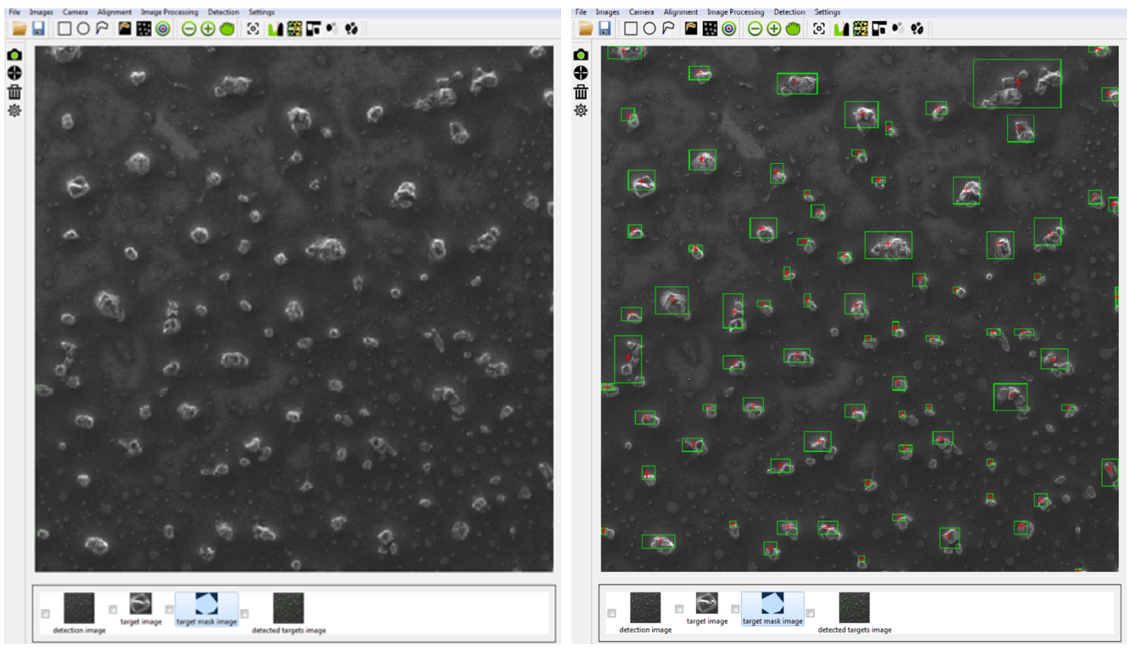

Figure 9: (left) Graphical user interface of “Targeter” software developed at European XFEL, showing example target detection image of gold nanoparticles. (right) Detected good target regions with target centre position marked by a red cross.

The next steps in Task 6.2 include electromagnetic pulse (EMP) testing of in-vacuum precision stages and the development of an in-vacuum microscope for sample positioning. Both projects have been closely discussed with the participating partners and the outcome of these developments will be made available to all facilities.

Correct operation of in-vacuum precision stages and motor drivers can be affected by EMPs impinging on the driver electronics and by return currents due to sample positive charging. These effects can result in temporary failure (motor shutdown, unsolicited movement of the stages during sample irradiation) or even permanent damage in the motor drivers or the motors themselves. Therefore, sample positioning systems in high-intensity and high-energy laser laboratories are normally protected by electrically isolating the motors from the sample and by disconnecting the motors during each irradiation.

EMP tests of in-vacuum precision stages have been organized in three steps. The first step was aimed at gathering information about stages currently used in high-power and high-energy laser facilities, identifying possible failure modes and planning EMP measuring systems. In the second step, EMP frequency and amplitude has been measured and linear stages have been tested outside the interaction chamber of the DRACO 150 TW laser system at HZDR. The third step will involve a dedicated test aimed at measuring EMP frequency, amplitude and spatial distribution inside and outside the vacuum chamber; at studying the effect of return currents in motors and control systems; and at providing quantitative indications on the required electrical insulation between motors and target holder.

In addition to these activities, WP6 members at HZDR co-organized the workshop “Building a Target Supply Network for Advanced Laser Light Sources” at HZDR in August 2016. The high level of interest generated by this event within the ALL-RI community resulted in WP3 members selecting it as a Joint Foresight Topic. This was described in detail in Section 1.2.3 (Task 3.3).

# 1.2.7 Work Package 7 – Pulse Characterization and Control (PUCCA)

**Task 7.1: Delivery of arrival time monitors between two independent pulsed light sources with femtosecond time resolution (HZDR, XFEL, ELI, PSI (Observer))**

In the development of the THz based timing tool (Task 7.1.1) a first prototype device was assembled at HZDR and is under testing (Deliverable 7.3). The device already fulfils many of the required benchmarks for the European XFEL with respect to dynamic range, time resolution and robustness. The current device is operating at a standard repetition rate of 100 kHz cw. The next development step to be performed at HZDR is to prepare the device so that the data handling can cope with the repetition rate of 4.5 MHz as envisioned for the demonstrator that will be set-up, tested and benchmarked at the ELBE accelerator (Deliverable 7.5). A critical risk to this work is the measurement of the maximum achievable repetition rate of the THz-based timing tool. The reason is that the envisioned detector for 4.5 MHz operation, the GOTTHARD 2 developed by PSI, might not be available for routine operation in time, so that the THz-based tool may not operate at 4.5 MHz.

The development of the liquid jet-based arrival time monitor for two independent laser pulses (Task 7.1.2) focussed on the complete characterization and control of different techniques for generation of fast-flowing liquid jets employing a flat sheet. Two different approaches are investigated at European XFEL. First, a colliding jet system had been built and set up, where the collision of two laminar round jets under an angle results in the formation of a flat sheet. This is shown in Figure 10.

By adjusting the liquid pressure, diameter, position and angle of the nozzles, the shape, thickness, flatness, stability and flow speed of the flat sheet can be modified. Typically, widths between 0.5 mm and 2 mm can be achieved, with a length of a few millimetres. This kind of jet requires rather high volumetric flow rates in the order of tens of millilitres per minute, however the liquid can be re-flowed (i.e. re-used) and the planned use of water mitigates this issue for the timing tool development. However it can be of concern for actual sample delivery and potential *in-situ* timing measurement. Until now, the jet had been optimized for the operation in atmospheric or helium environments, while a test of in-vacuum operation will be carried out as part of the further development of the system. For this type of operation and that in restricted areas (e.g. an interlocked area of a research facility) the jet had been equipped with motors and a camera for remote-controlled positioning and nozzle adjustment. To characterize this liquid jet system in terms

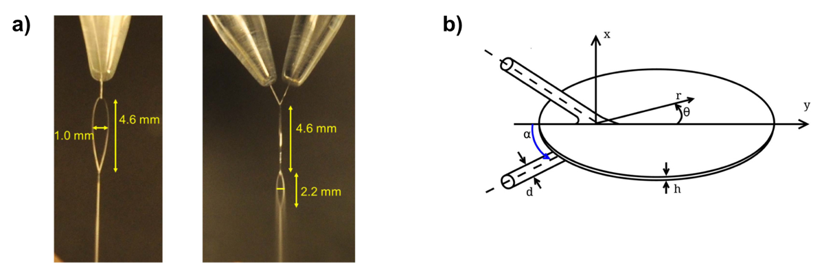

Figure 10: a) Photographs of a liquid flat sheet from two orthogonal directions showing the formation of a first sheet and a second, smaller one. b) Sketch of the flat sheet with notation used, from Ekimova *et al*., Struct Dyn 2 (5) , 054301 (2015).

of flow speed, flatness and thickness, a setup utilizing a high-framerate camera system (up to 500,000 frames per second and exposure times as low as 30 ns) as well as interferometric sensors have been implemented. It was found that stable flat sheets can be achieved with a thickness of 5 µm and flow-speeds in the range of 40 – 50 m/s, while at higher flow-speeds the sheet showed instabilities. However, the performance of the jet will be sufficient for appropriate sample volume replacement in a timing tool with MHz repetition rate.

During an experimental campaign in February 2016 at the Advanced Photon Source (at Argonne National Laboratory, USA) the utility of a 0.1 mm thick flat sheet jet was tested for timing tool purposes at MHz repetition rates. Such a liquid jet-based timing tool would allow the measurement of timing *in-situ*, i.e. directly at the sample position in contrast to traditional timing tools. For these measurements a synchronised laser is required, and this beamtime provided the opportunity to gain an understanding of the *in-situ* detection scheme together with the particular synchronisation scheme at MHz repetition rates. Since within PUCCA numerous facilities with different control systems are involved, knowledge of those is beneficial for further adaption and implementation of the envisioned timing tool besides the instruments of the European XFEL.

The proposed detection scheme for photon pulse arrival time determination using liquid jets was successfully tested during a separate measurement campaign at the XPP end-station of LCLS in April 2016. This included the generation of chirped, white laser light and the nearly collinear propagation to the x-ray beam, and spectral detection after interaction in a medium. Here, a different type of jet based on a slot in a thin foil sandwiched between two glass sheets was used (presently under investigation in the LCLS Sample Environment group).

The second type of jet under investigation within PUCCA at European XFEL is based on the gas dynamic virtual nozzle (GDVN) technique, where gas pressure is used to compress and elongate a single liquid stream to a thickness which can be two orders of magnitude lower than the initially round jet. By this, flat sheet widths of several hundred micrometres can be achieved, similar to those using the colliding technique. In contrast to that, here a significantly lower volumetric flow rate of approximately 100 µl/min is required, which makes this type of jet particularly useful for in-vacuum applications. Preliminary measurements of the thickness, carried out together with colleagues from LCLS in February 2017 utilizing the absorption of a certain dye, result in sub-1 µm thin, flat sheets for different operation conditions. Future developments will require the determination of flow speed and investigation of stable and reliable operation in vacuum. In Deliverable D7.2 the characterization of liquid jets and their results is described in detail.

The development of a liquid jet-based timing tool (Task 7.1.2) is on-going and will be finished in time for Deliverable 7.6 due in Month 36. A prototype setup is presently being implemented in a laser laboratory at European XFEL and will be tested with x-rays in a measurement campaign at the SACLA FEL in Japan in May/June 2017. In addition to the proposed detection scheme, a new scheme promising improved temporal resolution will be studied. As with the THz-based timing tool, a critical risk is the is the measurement of the maximum achievable repetition rate of the arrival time detector, as the envisioned detector for 4.5 MHz operation, the GOTTHARD 2 developed by PSI, might not be available, so that it may not be possible to operate the liquid jet-based tool at 4.5 MHz. Planning of the correlation measurement defined in Task 7.1.3 of the THz-based timing tool (Task 7.1.1) and the liquid jet-based arrival time detectors (Task 7.1.2) is on-going. For this, additional infrastructure at the different RIs will be required which might be beyond the duration of EUCALL.

**Task 7.2: Development of a wavefront sensor and analysis software (ESRF, Elettra, DESY, ELI, XFEL (Observer), PSI (Observer))**

ESRF hired in September 2016 a 24-month post-doctoral fellow position to reinforce its present staff for the production of the Deliverables on wavefront sensing. For this reason, the technical developments regarding the wavefront sensor are shifted in time in comparison to the developments of other diagnostic tools that started earlier. Work on the prototype and on producing a software package that will be released during the EUCALL project is now ongoing. This software will feature tools for wavefront analysis from different sources according to standard metrics. Computational efforts are deployed to provide an open source package written in Python (Task 7.2.2). The software development at Elettra/FERMI concentrates on the reconstruction of the optical parameters of the photon beam. Especially, the determination of the focal spot of the beam and the determination of the Zernike coefficients are of interest. Both developments follow different approaches for the wavefront sensor (Hartmann sensor at Elettra/FERMI; speckle tracking technique at the ESRF), but both benefit from the cooperation within PUCCA.

A prototype of the wavefront sensor was assembled and commissioned at the beamline BM05 of the ESRF (Task 7.2.1). The operation of the wavefront sensor is illustrated in Figure 11. Five experimental runs have been conducted so far in order to characterize the behaviour of the prototype.

These characterizations concern the optical distortion of the system and its absorption. Efforts were also deployed around the synchronization of the two detectors. Computing aspects, such as the fast data transfer and storage have been under study for several months now, with two potential schemes identified: fast local hard drive (SSD) or GBit connections to the facility with a buffer system.

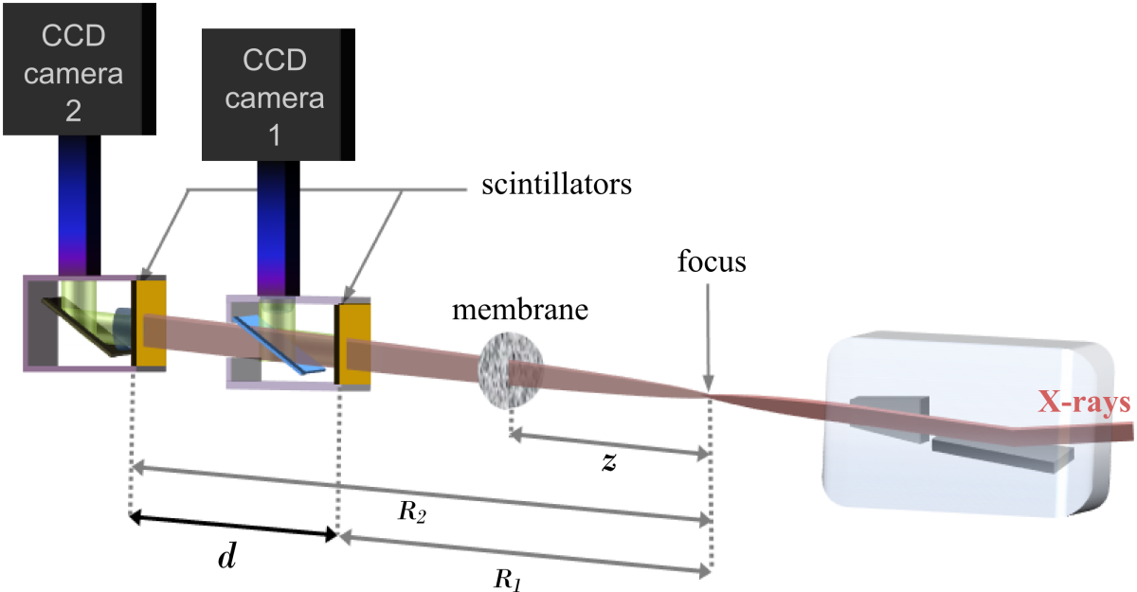

Figure 11: The operation of a speckle-tracking based wavefront sensor for hard x-rays, developed at the ESRF. Two images of a scattered x-ray beam are recorded simultaneously using CCD cameras, and the speckle in each image can be traced to determine the wavefront of the x-ray beam.

In March 2017, eight SSD fast hard drives, 1 TB each, were received at the ESRF. They will be integrated and tested in the computers controlling the data acquisition in the next period.Calculations and optimization regarding the right choice of scintillators with respect to the light wavelength and the luminescence decay time as compared to the pulse rate of the sources were performed. Two sets of scintillators have been identified to cover the energy range 8 – 40 keV.

**Task 7.3: Precise transparent intensity monitor (DESY, Elettra, XFEL)**

The improvement of the intensity monitor within the PUCCA framework concentrates upon the extension of the range of operation towards higher x-ray energies, as available at the European XFEL, as well as towards the lower pulse densities that will be delivered by the laser driven sources of ELI. The demands of synchrotron facilities, like the ESRF, range somewhere in between in respect to photon pulse density. Following an analysis by DESY of the working principal of gas phase based x-ray intensity monitors (Task 7.3.1), it was proposed to use a “Huge Aperture Amplifier” (HAMP) detector which is supposed to be a compact and robust single photoionization event sensitive detector working as an intensity monitor in the hard x-ray regime (Deliverable 7.1). This is illustrated in Figure 12. The HAMP will be sensitive down to single photoionization event detection to monitor pulses down to 1x104 photons per pulse in the soft x-ray regime or higher pulse density at lower cross-section. Because of the single particle detection scheme, the uncertainty due to low counting rates will be rather high for a shot-to-shot monitor scheme (see Deliverable 7.1). A prototype HAMP was completed in March 2017 and was characterized in April 2017 (during the second reporting period) at the Metrological Light Source of the Physikalisch-Technische Bundesanstalt, Berlin, to enable monitoring of the photon pulse energy on absolute scale. The prototype will be tested during the commissioning of the FXE instrument of European XFEL in 2017 (Task 7.3.2). Tests are planned at Elettra/FERMI, ESRF and ELI-Beamlines, but will be scheduled after FXE commissioning.

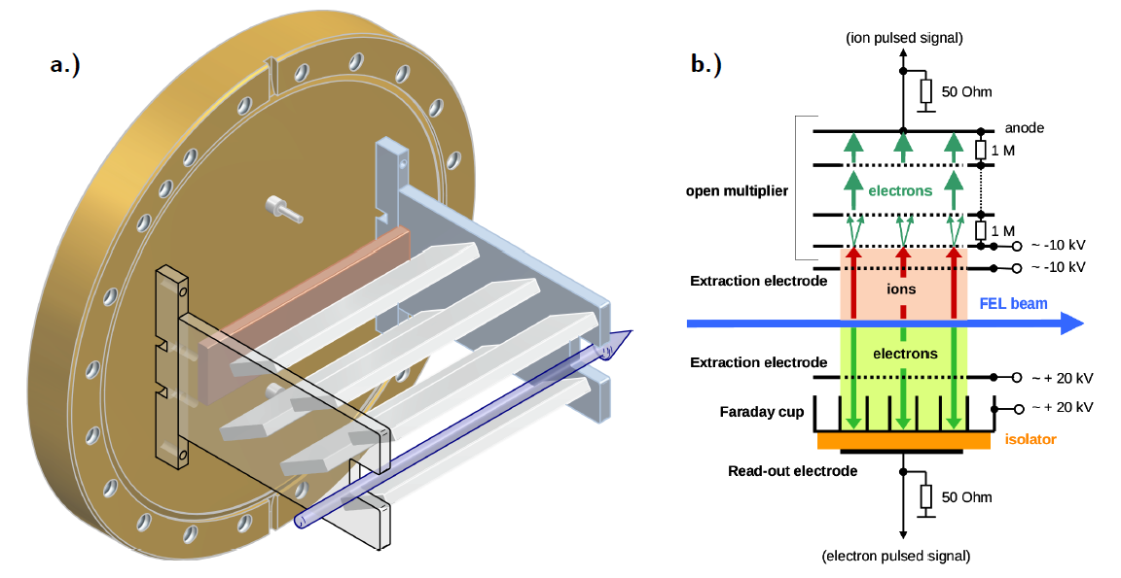

Figure 12: (a) Model of the "huge aperture open multiplier" (HAMP) detector sitting upon a CF160 flange. The dynodes are solid material to be able to operate it at high target gas densities. Only the ion detection part is shown. (b) Sketch of an improved gas monitor detector for low signal amplification based upon HAMP. The created primary charged particles are separated by a constant electric field towards two Faraday Cup type detectors facing each other. The fast electron signal can be used to determine the pulse intensity shot-by-shot. The slower photo-electrons are converted and amplified by dynodes into a secondary electron avalanche.

PUCCA’s studies of the new detector concept include the understanding of the material in use within these detectors. We were able to identify aging effects in the electronic structure of CuBeO samples at the oxygen k-edge which may influence the response of the material to incident particles. Changes of detector response over time are important information to operate online diagnostic devices.

A literature review showed that in exploiting the photoemission of noble gases to determine the intensity of x-ray pulses, the influence of resonances enhances the emission of electrons leading to extremely high charge states of the target gas, but the physical mechanism behind this processes is still under debate. In order to better understand the processes involved in the photoemission of the gas intensity monitor, PUCCA examined the behaviour of the open-shell system manganese upon irradiance of high energetic soft x-ray pulses of DESY’s FLASH FEL.

Beside gas phase intensity monitors based on photoemission to determine the pulse intensity of an FEL pulse train on shot-to-shot bases, tests have been performed with an streaking camera based system, proposed and operated by members of the group of AG Ehresmann, University of Kassel, to determine the pulse intensity and mode spectrum during two different beamtimes at PG2 at FLASH. The data evaluation is still ongoing, but first results are promising. The streaking method, though, is destructive; hence its usage as beamline infrastructure will be investigated further.

# 1.2.8 EUCALL Deliverables and Milestones

| No. / No. in WP | Month Due | Deliverable / Type | Lead | Status | Comment |
| --- | --- | --- | --- | --- | --- |
| D1 / D1.1 | 1 | Kick-Off Meeting / OTHER | XFEL | Completed | Meeting took place on 29/30 Oct 2015, report was submitted on 09.11.2015 |
| D2 / D2.1 | 6 | EUCALL Project website / OTHER | XFEL | Completed | Achieved on time |
| D3 / D2.2 | 6 | EUCALL Identity package / OTHER | XFEL | Completed | Achieved on time |
| D4 / D3.1 | 7 | SB terms of references / R | ELI | Completed | Achieved on time |
| D5 / D1.2 | 12 | 1st EUCALL Annual Meeting / OTHER | XFEL | Completed | Achieved on time |
| D6 / D4.1 | 12 | Design report and advanced photon-matter simulation software – short pulses/ R | HZDR | Completed | Achieved on time |
| D7 / D4.2 | 12 | Design report and advanced photon-matter simulation software – long pulses / R | ESRF | Completed | Achieved on time |
| D8 / D7.1 | 12 | Ultimate XGM sensitivities at FEL and ELI sources / R | DESY | Completed | Achieved on time |
| D9 / D6.1 | 13 | Design report for standard sample holder / R | XFEL | Completed | Achieved on time |
| D10 / D7.2 | 15 | Liquid jet capabilities: flat sheet versus microjet / R | XFEL | Completed | Achieved on time |
| D11 / D2.3 | 18 | Dissemination material / OTHER | XFEL | Completed | Achieved on time |
| D12 / D6.2 | 18 | Sample positioning device / DEM | LU | Partially Completed | Due to technical challenges and unexpectedly long delivery times the device could not yet be fully assembled and tested under UHV conditions. Will be fully completed in Sept. 2017. |
| D13 / D6.3 | 18 | Beta version of sample identification software / DEM | ELI | Completed | The author of the deliverable requested to insert a list of references to the already submitted document, so the final deliverable was submitted a few days late. |
| D14 / D7.3 | 18 | THz based arrival time monitor at FEL and ELI facilities / R | HZDR | Completed | Achieved on time |
| D15 / D1.3 | 20 | Mid-Term Review / R | XFEL | Scheduled | 21.06.2017 in Brussels |
| D16 / D1.4 | 24 | 2nd EUCALL Annual Meeting / OTHER | XFEL | Scheduled | 07-09.06.2017 at ESRF |
| D17 / D4.3 | 24 | Interoperability of simulation workflows / R | XFEL | In process |  |
| D18 / D4.4 | 24 | Generation of simulated coherent scattering data from plasma and non-plasma samples / R | ELI | In process |  |
| D19 / D6.4 | 24 | EMP-compatible stages / R | HZDR | In process |  |
| D20 / D3.2 | 30 | Synergy and innovation potential of EUCALL / R | ELI | In process |  |
| D21 / D6.5 | 30 | Sample holder with cooling and heating capacity / DEM | XFEL | In process |  |
| D22 / D6.6 | 30 | UHV microscope / DEM | DESY | In process |  |
| D23 / D7.4 | 30 | XGM prototype, calibrated and tested / DEM | DESY | In process |  |
| D24 / D1.5 | 36 | 3rd EUCALL Annual Meeting / OTHER | XFEL | In process | To take place at ELI (CZ) |
| D25 / D2.4 | 36 | EUCALL dissemination activities and exploitation / R | XFEL | In process | An internal document “EUCALL Dissemination Status” was circulated in November 2016, which summarizes all of WP2’s work to date. This will form the basis for this Deliverable |
| D26 / D3.3 | 36 | Optimum use of advanced light sources: challenges and potential / R | ELI | In process |  |
| D27 / D3.4 | 36 | Joint foresight topics for lasers and FELs in Europe / R | ELI | In process |  |
| D28 / D4.5 | 36 | Testing, validation, and example workflow / R | DESY | In process |  |
| D29 / D5.1 | 36 | Report on online 2D image processing / R | HZDR | In process |  |
| D30 / D5.2 | 36 | Report on high-speed data transfer and data injection / R | ELI | In process |  |
| D31 / D5.3 | 36 | Report on online processing of digitizer data / R | XFEL | In process |  |
| D32 / D6.7 | 36 | Automatic sample identification software / DEM | ELI | In process |  |
| D33 / D6.8 | 36 | Integration of sample stages with microscope / DEM | XFEL | In process |  |
| D34 / D7.5 | 36 | THz-based arrival time monitor / DEM | HZDR | In process | Operation at the full XFEL repetition rate of 4.5 MHz. may not be possible - this depends on the development of the GOTTHARD 2 detector which may not be available on time |
| D35 / D7.6 | 36 | Liquid-jet-based laser x-ray arrival time monitor / DEM | XFEL | In process | Operation at the full XFEL repetition rate of 4.5 MHz. may not be possible - this depends on the development of the GOTTHARD 2 detector which may not be available on time |
| D36 / D7.7 | 36 | CDR to build wavefront sensor for 8-25 keV / R | ESRF | In process |  |
| D37 / D7.8 | 36 | Wavefront analysis software package / OTHER | ESRF | In process |  |
| D38 / D7.9 | 36 | Test of XGM prototype at different light sources / R | DESY | In process | May not be possible to test prototypes at all kinds of light source, due to delays in commissioning of the RIs. Alternative RIs have been suggested. |

| No. / No. in WP | Month Due | Milestone | Lead | Status | Comment |
| --- | --- | --- | --- | --- | --- |
| MS1 / MS1.1 | 1 | User representatives are approved | XFEL | Completed | Achieved on time |
| MS2 / MS6.1 | 2 | Specification for sample holder and sample stages | XFEL | Completed | Achieved on time |
| MS3 / MS2.1 | 4 | Identity package | XFEL | Completed | Achieved on time |
| MS4 / MS6.2 | 4 | List of sample types for identification software compiled | XFEL | Completed | Achieved on time |
| MS5 / MS1.2 | 6 | Scientific Advisory Board | XFEL | Completed | Achieved on time |
| MS6 / MS3.1 | 6 | Synergy Board  (All members of the Synergy Board are in place.) | ELI | Completed | Completed in Month 9 as the death of the ELI director resulted in unexpected extra duties of WPL |
| MS7 / MS5.1 | 6 | Definition of data structures and inter­faces for software for processing, trans­fer, and injection of data | HZDR | Completed | Achieved on time |
| MS8 / MS6.3 | 6 | Specification of the UHV microscope | DESY | Completed | Achieved on time |
| MS9 / MS2.2 | 12 | Dissemination material | XFEL | Completed | Achieved on time |
| MS10 / MS3.2 | 12 | Programme for exchange of  experien­ce staff & user workshops | ELI | Completed | Achieved on time |
| MS11 / MS4.1 | 12 | Single modules operable | XFEL | Completed | Achieved on time |
| MS12 / MS7.1 | 12 | Design of an optimized XGM | DESY | Completed | Achieved on time |
| MS13 / MS6.4 | 15 | Specification of cooling and heating  demands for samples | XFEL | Completed | Achieved on time |
| MS14 / MS2.3 | 18 | User Communication | XFEL | Completed | Achieved on time |
| MS15 / MS3.3 | 18 | First results of analysis of WP3 SYNERGY | ELI | Completed | Achieved on time |
| MS16 / MS5.2 | 18 | Evaluation of test case implement­a­tions for processing of digitizer data and image analysis | HZDR | Completed | Achieved on time |
| MS17 / MS4.2 | 24 | First example simulation | XFEL | In process |  |
| MS18 / MS4.3 | 24 | Simulations interoperable | XFEL | In process |  |
| MS19 / MS5.3 | 24 | Performance evaluation of data transfer and injection algorithms | HZDR | In process |  |
| MS20 / MS7.2 | 24 | Construction of prototype XGM finished | DESY | In process |  |
| MS21 / MS7.3 | 24 | Wavefront tests at FEL, SR and ELI facilities | ESRF | In process | The ELI facility may not yet be available to users before the EUCALL project ends. In this context, we need to delay the date of delivery from M24 to M36 |
| MS22 / MS7.4 | 28 | Successful test of prototype XGM | DESY | In process |  |
| MS23 / MS7.5 | 30 | Wavefront software tests at ESRF | ESRF | In process |  |
| MS24 / MS4.4 | 36 | Tested and documented simulation code | XFEL | In process |  |

**Exploitation of EUCALL’s results**

All of EUCALL’s deliverables have been produced for a “Public” dissemination level and are publicly available to be downloaded from the EUCALL website. All software developed under EUCALL to date is open source and has been made available for download to users and RI operators from the online software repository “eucall-software”. Hardware developments within HIREP and PUCCA are being published as progress is made. Therefore no exploitation of EUCALL’s results is foreseen.

# 1.2.9 Publications from EUCALL or including EUCALL contributions

C. Fortmann-Grote *et al*., *Start-to-end simulation of single particle imaging using ultra-short pulses at the European X-ray Free Electron Laser,* IUCrJ (submitted)

C. Fortmann-Grote *et al*., *Simulations of ultrafast x–ray laser experiments*, SPIE Optics & Optoelectronics Conference Proceedings, Prague (submitted)

A. Meents *et al*., *Pink beam serial crystallography*, Nature Communications (submitted)

P. Roedig *et al*., *High-speed fixed-target serial virus crystallography*, Nat. Methods (submitted)

S. Klumpp *et al., Multiple Auger cycle photoionization of manganese atoms by short soft x-ray pulses*,New Journal of Physics (submitted)

I. Prencipe *et al*., *Targets for high repetition rate laser facilities: needs, challenges, perspectives*, High Power Laser Science and Engineering (2016) (accepted)

C. Fortmann-Grote *et al*., *SIMEX: Simulation of Experiments at Advanced Light Sources*, in “New Opportunities for Better User Group Software” Conference Proceedings. J. Phys. Conf. Series (accepted). Preprint: <https://arxiv.org/abs/1610.05980>

S. Kovalev *et al*., *Probing ultra-fast processes with high dynamic range at 4th-generation light sources: Arrival time and intensity binning at unprecedented repetition rates*, Structural Dynamics 4, 024301 (2017); doi: <http://dx.doi.org/10.1063/1.4978042>

A. Britz *et al*., *A multi-MHz single-shot data acquisition scheme with high dynamic range: pump–probe X-ray experiments at synchrotrons,* J. Synchrotron Rad 23 1409–1423 (2016); doi: <http://dx.doi.org/10.1107/S1600577516012625>

D. Goeries *et al*., *Time-resolved pump and probe x-ray absorption fine structure spectroscopy at beamline P11 at PETRA III,* Review of Scientific Instruments, Volume: 87 Issue: 5, Article Number: 053116 (2016); doi: <http://dx.doi.org/10.1063/1.4948596>

E. Zenker *et al*., Alpaka *– An Abstraction Library for Parallel Kernel Acceleration* 2016 IEEE International Parallel and Distributed Processing Symposium Workshops (IPDPSW) 00:  631-640 (2016); doi: <https://doi.org/10.1109/IPDPSW.2016.50>

E. Zenker *et al*., *Performance-Portable Many-Core Plasma Simulations: Porting PIConGPU to OpenPower and Beyond,* Lecture Notes in Computer Science 9945: 293-301 (2016); doi: <http://dx.doi.org/10.1007/978-3-319-46079-6_21>

# 1.3 Impact

The information in section 2.1 of the DoA is still relevant.

2. Update of the plan for exploitation and dissemination of results

The produced EUCALL brochure provides information about EUCALL’s partners and activities and is aimed in general toward a non-scientific audience. The level and style of the information presented is designed to be attractive and accessible to young people. The brochure does not include detailed information about the specific activities of WP3 or the advanced technologies being developed within WPs4-7. Separate documents which describe the activities of WPs 3,4,6,7 with a matching layout to the EUCALL Flyer are therefore under development, to be available in time for EUCALL’s first exhibition participation in April 2017. These documents have been developed jointly with the WP members and have a higher technical level than the brochure. Distribution of these new documents at exhibitions will also assist EUCALL in engaging industrial audiences of the technologies being developed by the project, which was not previously part of the plan for the dissemination of results.

3. Update of the data management plan

An explicit data management plan for EUCALL was not defined. The data produced by EUCALL are made available to EUCALL beneficiaries.

4. Deviations from Annex 1 and Annex 2

# 4.1 Tasks

**Correction to DoA:**

In “Description of Work: WP7 – PUCCA: Pulse Characterization and Control” – Page 158/249 of the Grant Agreement – “A prototype device for hard x-rays and extensive software needed for fast interpretation of the recorded data will be developed. This software development can then be inspected and altered by HIREP to adapt to the MHz readout needs of XFEL and other high repetition rate sources.” This is an error and should be corrected to “This software development can then be inspected and altered by UFDAC to adapt to the MHz readout needs of XFEL and other high repetition rate sources.”

**Deviations from DoA:**

**New Goal for WP3 – wayforlight database**

WP3’s development of the wayforlight database to include the data recorded in the WP3 super-matrix will be a resource neutral expansion of WP3’s activities and is not expected to impact on the fulfilment WP3’s other tasks.

**New Goal for WP4** **–** **‘laser plasma accelerator based coherent light source’**

The extension of SIMEX’s capabilities to include simulations of laser plasma accelerator based coherent light sources will be performed by ELI, with support from European XFEL. The simulations of scattering from short-pulse laser produced plasmas will be implemented and performed by HZDR, rather by ELI as initially planned. This will not affect the use of resources or the fulfilment of other tasks within WP4.

**WP7 Task 7.2.1 – Wavefront sensor**

As mentioned in Section 1.2.7, the achievement of a repetition rate of 40Hz is now certain for the wavefront sensor. However, to fully benefit from this wavefront sensor, European XFEL (which operates with a 4.5 MHz pulse repetition rate) will require the discrimination of each pulse. PUCCA members are now deploying supplementary efforts in this direction. This includes the search for higher speed imaging systems and fast decay scintillators.

To date tests have only been performed using synchrotron radiation at the ESRF. Tests at the European XFEL are planned for June-August 2017. Tests at ELI-Beamlines are under evaluation. Alternative laser-based sources must be considered as the ELI-Beamlines facility may not be available to users before the end of the EUCALL project. In this context, we need to displace the date of delivery of Milestone M7.3 from M24 to M36. The wavefront sensor will be tested at synchrotron and FEL sources until Month 24. If ELI remains unavailable, we consider the following alternative optical laser facilities for testing before Month 36:

* Laboratoire d'Optique Appliquée (LOA), France
* Central Laser Facility (CLF) at Rutherford Appleton Laboratory, UK
* ATLAS facility near Munich, Germany
* Infrastructure of Nanostructures and Femtoscience (INF) Advanced Light Source, Canada

# 4.2 Use of resources

**Budget transfers:**

During the first project period the following budget transfers were implemented:

|  |  |  |  |
| --- | --- | --- | --- |
| **Amount** | **Budgeted at** | **Transferred to** | **Justification** |
| Direct costs:  15,200 Euro | European XFEL | HZDR | Organization and implementation of the 1st Annual Meeting at HZDR, Dresden.  This includes 1.15 PM which were transferred (WP1) |
| Direct costs:  1,300 Euro | European XFEL | ELI-DC | Costs for and exhibition at the LASER World of PHOTONICS 2017 in Munich, Germany. (WP2) |
| Direct costs:  Xx Euro | European XFEL | HZDR | Costs for Open Access publication fee in “Structural Dynamics”. (WP2) |

Table 4: Budget transfers between beneficiaries.

The procedure to move the costs for the Annual Meetings to the respective beneficiary where the meeting takes place has been agreed by the SC and the project office at the European Commission. This is also foreseen for the second reporting period. The procedure also will be implemented for workshops organized within WP3.

As only European XFEL has allocated funds for Open Access publication fees (WP2), future fund transfers are foreseen to other beneficiaries for their own Open Access publication costs during the second reporting period.

**Reallocation of Person Months**

Compared to Table 1.3.6. (WT6 Summary of project effort in person-months) of the Grant Agreement, the following corrections to the allocated person months (PMs) have taken place:

**WP1 Management**: European XFEL gives 1 PM each to the organizers of the Annual Meetings (HZDR, ESRF; ELI (IP-ASCR/ELI-Beamlines)).

**WP3 Synergy**: originally ELI-DC had 60 PM at ELI-DC. This was changed to 24 PM at ELI-DC and 36 PM at IFIN-HH/ELI-NP.

**WP4 SIMEX**: 36 PM were moved/corrected from IFIN-HH/ELI-NP to ELI-HU/ELI-ALPS.

**WP5 UFDAC and** **WP6 HIREP**: ELI-HU/ELI-Alps transferred 8 PM from WP6 HIREP to WP5 UFDAC, meaning that it delivers 26 PM in WP5 UFDAC and none in WP6 HIREP.

IP-ASCR/ELI-Beamlines transferred 8 PM from WP5 UFDAC to WP6 HIREP, meaning that it delivers 4 PM in in WP5 UFDAC and 18 in WP6 HIREP.

For all changes mentioned, the budget and the tasks described in the Grant Agreement Annex 1 (DoA) and Annex 2 (budget) remain unchanged.

**WP5 UFDAC**: Both DESY and IP-ASCR/ELI-Beamlines provided more PMs than anticipated. At IP-ASCR/ELI-Beamlines, a less senior person was hired to perform the tasks, therefore the number of PMs could be increased.

**Modification to DoA**: **“Other direct costs” of ELI**

**ELI Travel Costs**: Originally all travel costs in the amount of 82,000 Euro were allocated to ELI-DC. Therefore some costs were distributed to the ELI pillars to fund the travels of employees at each pillar. The following transfers were made compared to the other direct costs stated in the Grant Agreement Annex 2:

* Additional 30,500 Euro to IP-ASCR/ELI-Beamlines
* Additional 12,000 Euro to ELI-HU/ELI-ALPS
* Additional 12,500 Euro to IFIN-HH/ELI-NP

**Correction to DoA**: **“Other direct costs” of ELI**

In Table 3.4b “Other direct cost” per beneficiary where these exceed 15% of their personnel costs – Page 168/249 of the Grant Agreement (shown below in Table 7) – under [ELI – Equipment] is listed “Workstation for prototyping workflow implementations (WP3)”. This is an error and is intended for WP4. This correction will not influence the estimated costs.

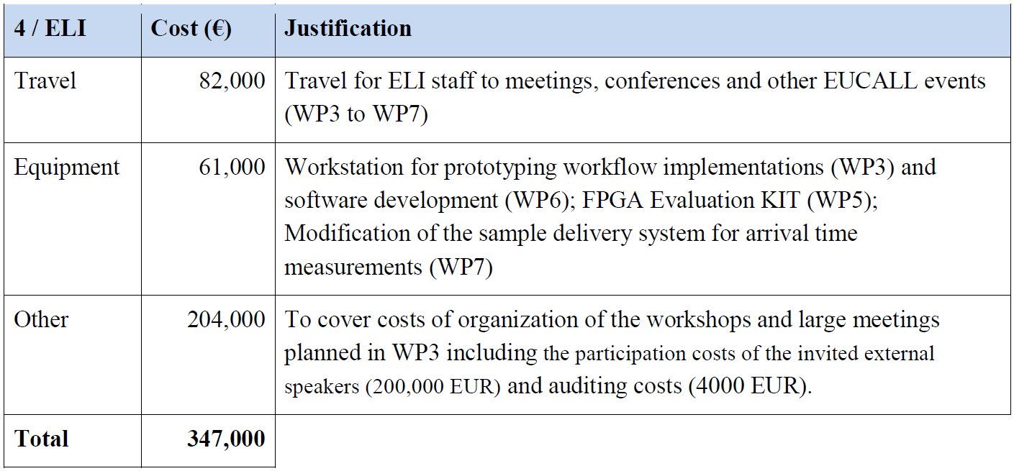

Table 7: Selection from Table 3.4b of the EUCALL Grant Agreement, containing an error in WP allocation.

**Underspending within the first project period**

The financial report from EUCALL’s first reporting period reveals underspending in the project funds from some of the beneficiaries. The Coordinator plans to address this and determine appropriate mitigation measures during the next EUCALL SC meeting (07.06.2017).

# 4.2.1 Unforeseen subcontracting (if applicable)

Not applicable.

# 4.2.2 Unforeseen use of in kind contribution from third party against payment or free of charges (if applicable)

Not applicable.

# Annex 1: SAC Report 2016

**EUCALL SAC Report**

SAC Meeting 20 & 21/9/2016

SAC members:

Prof. Mike Dunne (SLAC)

Prof. Jon Marangos (Imperial College London)1

Prof. Paul Morin (SOLEIL)

Prof. Kiyoshi Ueda (Tohoku University)

Prof. Marc Vrakking (Max-Born Institute, Chair)

September 26th 2016

12nd day only, via Video Conference

**Introduction**

The Scientific Advisory Committee (SAC) of the European Cluster of Advanced Laser Light Sources (EUCALL) had its first meeting in Hamburg on September 20th and 21st. During the meeting the SAC received an introduction to the goals of the EUCALL project, as well as progress reports on the development of the project during the first of its three years. The SAC would like to thank the members of the EUCALL project for their hospitality during the meeting, and would particularly like to acknowledge the support provided by Dr. Graham Appleby. In the current document the main conclusions and recommendations of the SAC are summarized. The report follows the Work Package format of the EUCALL project.

As a result of its meeting, the SAC has a very positive impression of the developments that have been initiated in the framework of the EUCALL project. The activities of EUCALL come at a time where a number of large-scale research infrastructures in Europe that will offer light sources in the XUV/X-ray wavelength range with unprecedented specifications are approaching the start of user operations. This makes both the technical developments within EUCALL as well as the synergy-building activities within EUCALL highly relevant. Importantly, the relevance of EUCALL extends beyond the present project in two different ways. On the one hand, the technical developments in the EUCALL project are not only relevant for the facilities that are directly involved (i.e. funded) in the project, but are of significant importance to other facilities offering advanced laser light sources (an important example being LCLS) that are not directly involved right now, but that could profitably be involved in the activities within EUCALL on rather short notice. On the other hand, the relevance of the EUCALL project is not limited to the project period, but a strategy should urgently be developed to sustain the synergies that are developed within the EUCALL project beyond the project duration.

**Work Package 3 - Synergy of Advanced Light Sources**

The Synergy Work Package pursues a three-fold goal:

1) Analysis and promotion of the efficient use of facilities

The SAC extensively discussed a table that is currently being compiled with characteristics of the light sources and beamlines offered by a number of facilities (mostly centering on the large-scale facilities within EUCALL, but also including a limited number of entries from lab-scale sources). This table was initially intended as an internal EUCALL document facilitating the uncovering of synergies.

The SAC suggests that this table be developed into a tool that is made available to the user community, facilitating the process of finding the right facility for one’s interest. In this context, the following further suggestions were made:

➢ The table/tool ought to include an assessment of the particular strengths/weaknesses of a particular light source or instrument, thus emphasizing its unique features. To be able to do so requires that the EUCALL project management motivates the facilities to fully participate and lend their support by providing all required data.

➢ A scoring system should be introduced that selects a limited number of available instruments on the basis of user-provided input, and thus directs the users to a limited number of recommended facilities. This requires that the data is kept in a database format, rather than in the form of a table. In order to score the individual light sources and instruments, a procedure is recommended involving a questionnaire that is sent to community experts.

➢ The EUCALL management should ensure that the data underlying the table/tool is kept up to date, and should strive that future updates of the table/tool become one of the responsibilities of a future project succeeding the EUCALL project.

➢ The data that is collected and used to score the different light sources and facilities should be considerable more detailed than in the preliminary table that was distributed. Entries should include the wavelength range and tunability, the pulse duration, the power and intensity, the temporal and spatial resolution, the repetition rate, etc. of the various light sources, the capabilities of available experimental end stations, as well as the availability of relevant sample preparation and data collection and analysis capabilities, etc. When compiling the table it is recognized that some of the desired numbers may not yet be available for some of the future facilities. This holds in particular for some of the secondary sources offered by ELI.

➢ The SAC believes this will serve an important additional purpose – of driving the high power optical laser community to focus on the performance parameters of these secondary sources, which should facilitate a closer interaction with the accelerator/FEL community, as well as directing the host facilities’ attention to application-relevant, user-facing parameters (rather than the traditional focus on the specification of the driving lasers).

➢ The data collection should be extended beyond the large-scale facilities that form the core of the EUCALL project. The involvement of the Laserlab Europe and the FELs of Europe consortia can be exploited to bring this about.

➢ In addition to serving users, the data collection and its integration in a tool can be used as well to identify gaps in the parameters that the current facilities are offering, which may motivate the development of new facilities or capabilities.

2. Analysis and promotion of the innovation potential of the facilities (technology transfer)

The SAC recommends performing a survey of both successful and unsuccessful technology transfer and industrial engagement efforts. In doing so, it is important to collect best practices, by involving both staff employed by the facilities that is devoted to technology transfer, as well as the investment community (e.g., venture capital firms and private foundations) that drive developments from scientific demonstration to industrial/commercial/medical applications. Moreover, the SAC recommends performing a survey among current industrial users of the synchrotrons, who under favorable conditions may be willing to share their past experiences, lessons-learned, and motivation for the existing or future light sources that are relevant to EUCALL.

It is also advisable to analyze the successful knowledge transfer model that exists in Japan (e.g. at SPring-8), where the government and industrial partners are strongly involved. In Japan, the future development of light source infrastructures strongly relies on the involvement of industry. Within Europe, the successful engagement of industry by Diamond Light Source should be closely studied.

While promoting knowledge transfer, the SAC advises that EUCALL at the same time promotes an awareness among the various stake-holders (such as the EU) for several perceived negative side-effects of technology transfer, in particular the risk of blocking progress by an over-emphasis on the importance of protecting intellectual property. Along these lines, EUCALL could perform a case study on examples of open-source / open-innovation developments that have successfully driven technology transfer.

3. Identification and development of the combined research potential of the infrastructures

The SAC recommends that within the timeframe of the EUCALL project the data collection on existing instrumentation and innovation activities (see 1 and 2) is used to define future strategies, both in terms of promoting novel scientific areas and in terms of sustaining the technical and operational initiatives developed by the EUCALL project.

The SAC supports the ideas for 4 foresight activities that are currently under consideration, namely

a. a workshop on new scientific applications of lasers + X-rays

b. a workshop on targetry

c. a workshop on future strategies for Research Infrastructure operators and policy makers

d. a workshop on theory/simulation/computing and data handling

Different from the ideas presented to the SAC by the EUCALL project management (which aimed at the identification of the future users interested in exploiting laser+FEL capabilities), the SAC recommends a less instrumental and more science-driven approach towards uncovering future scientific applications. The SAC recommends that an attempt is made to raise awareness in the community of the future possibilities brought about by the new advanced laser light sources, by performing a number of case studies. The goal of these case studies, which are to be performed for a number of important research questions (e.g. artificial photo-synthesis, light-induced phase-transitions, etc.) will be to identify how a portfolio of existing sources have been used in the past, as well as how key players in these research fields imagine that the advanced laser light sources may be used in future. The SAC offers its help in identifying suitable research fields and/or key individuals for the case studies that could be interviewed.

In order to permit a smooth transition of the EUCALL project into a future project that seeks to sustain the outcome of the EUCALL project, the SAC recommends that the next SAC meeting (June 2017) should include a presentation by the EUCALL management on the anticipated follow-up, thus making it possible that a new proposal can benefit from a workshop involving the Research Infrastructure operators held later in 2017. Open questions to be cleared until then are the possible involvement from industry and identification of the group of people that may at this point take the lead in the proposal. In the latter context a possible leading role by representatives from the user community is suggested.

**Work Package 4 – Simulation of Experiments (SIMEX)**

Within the SIMEX Work Package a simulation platform is developed and implemented for users and facility operators that allows comprehensive simulations of experiments at the various light sources. The SAC was delighted by the presentation of the simulation tool, and considers this development an extremely important contribution from EUCALL to the user community. In view of its tremendous potential, the SAC considers it essential that application of the tool is advertised beyond the EUCALL project, and that continuation of this development becomes an integral part of a follow-up project. The SAC considers that the modular, open source approach that is taken is the right approach at the right time, and expresses the hope that the tool will be developed into a global tool that is available and used by researchers around the world. One may well imagine that in future, use of this simulation tool will become a standard part of the application for beamtime at some of the advanced laser light sources. Indeed, it may become a pre-requisite for gaining beamtime in certain cases, in order to demonstrate the quantitative credibility of an experimental concept (such a position would mirror the approach taken by large-scale infrastructures such as NIF and LHC). Accordingly, it is essential that the facility managers are made aware of the power of this simulation tool, and motivated to adopt and promote it. Specifically, the SAC believes it is incumbent on the major facilities to take a leading role in sustaining an enduring level of support for this activity, as a service to the user community (similar to the provision of major detectors, instruments control systems, and sample delivery technologies).

**Work Package 5 – Ultrafast Data Acquisition (UFDAC)**

The extreme specifications of some of the novel laser light sources bring about challenges in data acquisition, processing, transport, storage and analysis that are to a large extent unprecedented. Accordingly the SAC welcomes the efforts that are made within the EUCALL project to optimize and standardize data acquisition-related issues within the EUCALL-consortium. In the presentation of the UFDAC Work Package, the SAC saw strong evidence that the EUCALL project is establishing synergies and is making progress towards convergence of the – initially – quite diverse approaches taken by different facilities. The SAC supports the approach separating abstract concepts (e.g. “scalability”) from concrete hardware implementations, and supports the open access approach that is taken. In doing so, it is important that the EUCALL team maintains its technological neutrality, and seeks to drive a balanced dialogue between the major facility infrastructures and their user communities. If the UFDAC Work Package continues along its promising trajectory, there is the potential to make an important contribution that will facilitate the mobility of users from one facility to another.

**Work Package 6 – High Repetition Rate Sample Delivery (HIREP)**

The activities in the HIREP Work Package are focused on the development of solid targetry that can be used in 10 Hz experiments that will first and foremost be carried out at Eu-XFEL, and perhaps to some extent at ELI, although the typical repetition rate of “single shot” experiments on solid targets there will typically be substantially lower for some beamlines, and suffer from markedly different constraints (e.g. fratricide) compared to biomedical applications. In some cases, local solutions appear to be already available.

While the SAC acknowledges the importance of sample delivery, several concerns were expressed. In the opinion of the SAC, other forms of sample delivery are important as well (e.g. the liquid jets that are used in Work Package 7 for pulse arrival time characterization, as well as tape-based delivery of 2D and 3D objects, and even gas-injector based systems under development by the fusion community). These are omitted from the activities that are pursued within HIREP, whereas the actual work that is carried out within HIREP may be less relevant than intended as a result of important developments that have recently taken place at the Diamond synchrotron facility, at SACLA and at LCLS, where chip-mounted samples can meanwhile be moved at 120 Hz. Accordingly, it is not clear to the SAC what added value is currently generated within the HIREP Work Package, and what is the true level of generalization for multi-facility deployment.

Moreover, when developing solutions for sample delivery within EUCALL, the SAC urges the development of solutions that are not only suitable for new facilities, but than can be applied with modest effort by existing facilities. It is not clear to what extent this is presently the case.

**Work Package 7 - Pulse Characterization and Control (PUCCA)**

The activities in PUCCA are focused on various types of pulse characterization and control, in particular intensity monitoring (a system similar to the GMD system at FLASH), wave front sensing (e.g., the extension of Hartmann-type detectors to the hard X-ray regime) including the development of the required software, and arrival time measurement using liquid jets.

While all these topics are important in their own right, the SAC is of the opinion that the emphasis within PUCCA really ought to be on the development of arrival time tools, which are currently also being pursued at LCLS and SACLA, and high-sensitivity non-invasive wavefront measurements (such as the speckle-based system suggested by PUCCA). Such activities have broad applicability across different facilities, and can take advantage of emergent work in the US and Japan. Work on finding the right method for laser vs. X-ray arrival time measurements with – potentially - sub-femtosecond time-resolution ought to be pursued with a very high priority.

The work on speckle-tracking wavefront sensing appears to be very promising. Regrettably it appears to be hampered by a lack of interest from the community within the project (ELI) that has most expertise on this issue.

The scope of applications of the GMD-like intensity monitors should be clarified. It is unclear if the technique can be applied at ELI, so other solutions ought to be considered as well.

# Annex 2: EUCALL Response to the SAC Report 2016

**Assessment of specific SAC Recommendations:**

The SAC report specifically addresses the activities in WP3 (SYNERGY), WP6 (HIREP) and WP7 (PUCCA). The EUCALL coordination team and the work package leaders have analysed these recommendations and have produced detailed responses to these recommendations. These responses have also been further discussed with the EUCALL SC.

In the following, the most important points are addressed for each group of recommendations:

**1. WP3 – Table with light source characteristics:**

The SAC has made several detailed recommendations to this table and the majority of them has been implemented and is worked upon. However, a few recommendations require a detailed response as they concern the EUCALL spirit and scope.

The suggested inclusion in the table of particular strengths/weaknesses of an instrument and the introduction of a ‘scoring system’ can from the point of the user community be consi¬dered as useful tools to select specific instruments based on their performance. However, for the facilities engaged in EUCALL, in particular, the scoring system is introducing a competitive element, which can have negative impacts for EUCALL. A direct competitive element is not in line with the EUCALL spirit, which has been described in the proposal as analytical and disseminative. EUCALLs aim is to analyze the current situation of the advanced laser light sources and their instruments, and to present this analysis including recommendations. This analysis is foremost addressing the facility managements in order to allow them to take decisions contributing to the sustainability of their facilities. A competitive element could hamper such an analysis, rendering it useless. In addition, many of the participating facilities and their instruments are in an early state of operation and are considered to still undergo development and specialization. The expectation is that a suite of complementary instruments will provide the best research possibilities for Europe’s researchers. EUCALL wants to contribute to this process in a positive way and therefore avoids introducing a direct compe¬ti¬tive element at this early stage. Highlighting of particular strengths of facilities/ instru¬ments will be attempted, to provide facility operators and users additional orientation.

The suggestion to make the table sustainable and a ‘tool’ for facility operators and users is taking the initial EUCALL goal, namely to use this table as a basis for the analysis of facilities and instruments, to a long-term community goal and project. A sustainable implementation is clearly beyond the EUCALL scope and requires additional commitments by the EUCALL part¬ners and beyond. Within EUCALL we can propose a model how such a table could be structured and maintained in a sustainable fashion (technically, but also organizationally) and, probably, develop the technical means and a starting version. Such a cross-community facility information platform could be considered as one of the core activities of a long-term collaboration of the participating and related advanced laser facilities.

**2. WP6 – High Repetition Rate Sample Delivery:**

The SAC recommendations suggest redirecting the activities in this WP, based on the assumption that parallel developments at other facilities have made the developments within EUCALL obsolete. We are not in agreement with this assessment for the following reasons:

The main focus and added value of this activity consists in establishing a standardized, user friendly and "intelligent" sample holder (carrier frame and target frame) which fulfils the requirements defined by different types of samples and specific types of experiments. The instruments of the participating facilities will feature standardized carrier frames and users will mount their samples on target frames optimized for their experiment and sample. The target frame can carry different batches of samples to be studied and will fit to the carrier frames. Furthermore, to locate sample on a specific target frame a software tool set is developed to transfer fiducialized data, e.g. obtained by users in their home laboratory through optical (2D/3D) microscopy using the fiducial marks on the sample frame or on the target itself, to the reference frame of the respective facility instruments. Finally, the target frame exhibits a unique identification label to assign the correct target position dataset and to generate a history for each target frame. We are not aware of any development at an existing facility providing a similar goal in terms of user friendliness and standardization.

The concentration of sample repetition/exchange rates of max. 10 Hz is indeed due to the requirements of European XFEL and ELI, but also of the entire high power laser com-munity. Higher repetition rates as used in x-ray only or with moderate laser power at LCLS, FERMI, SACLA or SwissFEL, but also at SR facilities, had not initially been considered. In order to recognize these capabilities and to enable in the future using the standardized target/ carrier frames also at these facilities we will analyze the impact of higher rates to our designs. In case we encounter limitations possible mitigation scenarios will be investigated. It has to be noted that this activity exceeds the EUCALL scope, and therefore it has to be analysed how much effort could be placed here. Independently, we will actively look for collaboration with other facilities, operating and new, with a need of such sample replacement with the goal to provide users an as much as possible standardized approach.

**3. WP7 - Pulse Characterization and Control:**

The SAC recommendations address various points to be clarified, the prioritization of the further development of the ‘timing-tool’, involvement of ELI groups in the speckle wavefront sensor project, and clarification about the usefulness of the GMD sensors for laser-based facilities.

We agree that the development of the pulse arriving tool(s) is crucial for the different facilities dealing with pump–probe experiments, in particular when approaching single femtosecond or even sub-fs time resolution. However, it needs to be noted that so far this need has been limited to accelerator-based facilities, while laser-based facilities use the synchronization of pulse arrival due to pulse splitting or optical synchronization methods. Focusing on pulse-arrival methods would turn this WP much less relevant for laser-based facilities. However, we believe that the results from the flat liquid sheet method and the THz streaking of accelerator-driven light sources will be of interest for the upcoming laser-based light source user facilities.

The wavefront sensing project has actually received a lot more attention than initially anticipated and the WP now covers activities for the entire energy range from the soft x-rays (actually: UV-vis) to the hard x-ray regime using different approaches. ELI currently builds up the secondary short-wavelength sources and does not have the resources for their detailed characterization, e.g. by wavefront measurements. However, EUCALL will strive to keep the relevant people and groups at ELI, in particular the ELITRANS WP on diagnostics fully informed about the results of this WP.

The applicability of residual gas based intensity monitors to laser-based sources is an issue under study at present. The meaningfulness of this type of detectors has been recognized by all parties (including the laser-based facilities), but details of their implementation are still to be solved. These activities are pursued as well in the ELITRANS WP on diagnostics.

PUCCA also strives for a close collaboration with SACLA and LCLS. A dedicated session within the PHOTONDIAG conference in May 2017 was organized to discuss joint activities in the application of wavefront sensing, time-arrival measurement and intensity monitoring, maybe joint campaigns at either of these FEL facilities or at SR beamlines.

# Annex 3. List of Activities and Events in EUCALL, First Reporting Period

| WP1 | | | |
| --- | --- | --- | --- |
| Date | Title | Venue | Type of Event |
| 29-30.10.2015 | EUCALL Kick-off Meeting | European XFEL/DESY | Organization of a Workshop |
| 30.10.2015 | Steering Committee Meeting | European XFEL | Board Meeting |
| 14.12.2015 | Executive Board Meeting | Via Telcon | Board Meeting |
| 14.03.2016 | Steering Committee Meeting | Via Telcon | Board Meeting |
| 03.04.2016 | Executive Board Meeting | Via Telcon | Board Meeting |
| 31.08-02.09.2016 | 1st Annual Meeting | HZDR | Organization of a Workshop |
| 01.09.2016 | Steering Committee Meeting | HZDR | Board Meeting |
| 02.09.2016 | Executive Board / Synergy Board Meeting | HZDR | Board Meeting |
| 20-21.09.2016 | Scientific Advisory Committee Meeting | European XFEL | Board Meeting |
| 12.12.2016 | Executive Board Meeting | Via Telcon | Board Meeting |
| 18.01.2017 | Steering Committee Meeting | Via Telcon | Board Meeting |

| WP2 | | | |
| --- | --- | --- | --- |
| Date | Title | Venue | Type of Event |
| 16.11.2015 | Large Scale Research Infrastructures - Maximizing the potential for renewed growth in Europe | Brussels, BE | Participation to a Conference |
| 22-27.11.2015 | International Conference on Extreme Light | Bucharest, RO | Participation to a Conference |
| 27-29.01.2016 | DESY/XFEL User's Meeting 2016 | DESY | Participation to an Event other  than a Conference or a Workshop |
| 09-11.03.2016 | Diffraction Limited Storage Ring Workshop | DESY | Participation to a Workshop |
| 06.04.2016 | Presentation at DESY Photon Science Weekly Meeting | DESY | Participation to an Event other  than a Conference or a Workshop |
| 03.05.2016 | Invited Presentation at Diamond Light Source | Diamond Light Source | Participation to an Event other  than a Conference or a Workshop |
| 25.05.2016 | Invited Presentation at Stiftung Institut für Werkstofftechnik | Bremen, DE | Participation to an Event other  than a Conference or a Workshop |
| 05.06.2016 | High time for Beam Time | ELI-ALPS | Participation to an Event other  than a Conference or a Workshop |
| 06.06.2016 | High time for Beam Time | ELI- Beamlines | Participation to an Event other  than a Conference or a Workshop |
| 07.06.2016 | High time for Beam Time | Bratislava | Participation to an Event other  than a Conference or a Workshop |
| 10-11.06.2016 | 'Photon Science Strategy Panel' (PSSP) / LEAPS | ESRF | Participation to an Event other  than a Conference or a Workshop |
| 30.06.2016 | CREMLIN WP2 Workshop | Lund, SE | Participation to a Workshop (of another Horizon 2020 project) |
| 24.07.2016 | Science Communication Event | Manchester | Training |
| 22-26.08.2016 | ELI and HILASE Summer School 2016 | ELI-Beamlines | Participation to an Event other  than a Conference or a Workshop |
| 04-07.09.2016 | Science@FELs 2016 Conference | Trieste, IT | Participation to a Conference |
| 27.09.2016 | Presentation at XFEL Photon Beam Science Meeting | European XFEL | Participation to an Event other  than a Conference or a Workshop |
| 03-05.10.2016 | International Conference on Research Infrastructures | Cape Town, South Africa | Participation to a Conference |
| 20.10.2016 | FELs of Europe SC Meeting | PSI | Participation to an Event other  than a Conference or a Workshop |
| 25-27.01.2017 | DESY/XFEL User's Meeting 2017 | DESY / European XFEL | Participation to an Event other  than a Conference or a Workshop |
| 29-30.03.2017 | Studies of Dynamically Compressed Matter with X-rays | ESRF | Participation to a Workshop |

| WP3 | | | |
| --- | --- | --- | --- |
| Date | Title | Venue | Type of Event |
| 31.03.2016 | Synergy Board Meeting | Via Telcon | Board Meeting |
| 09-10.03.2016 | Meeting of European Synchrotron User Organization | ESRF | Participation to an Event other  than a Conference or a Workshop |
| 12-16.06.2016 | Ultrafast X-ray Summer School | Stanford, USA | Training |
| 29-30.08.2016 | Building a Target Supply Network for Advanced Laser Light Sources | HZDR | Co-Organization of a Workshop with WP6 |
| 13-14.10.2016 | WP3 Meeting | European XFEL | WP Meeting |
| 10.11.2016 | Synergy Board/WP3 Meeting | Via Telcon | WP Meeting |
| 29-30.11.2016 | Extreme Light Scientific and Socio-Economic Outlook | Paris, FR | Participation to a Conference |
| 08.12.2016 | Synergy Board/WP3 Meeting | Via Telcon | WP Meeting |
| 10.03.2017 | Synergy Board/WP3 Meeting | Via Telcon | WP Meeting |
| 10.03.2017 | WP3 Meeting – European Open Science Cloud | Via Telcon | WP Meeting |

| WP4 | | | |
| --- | --- | --- | --- |
| Date | Title | Venue | Type of Event |
| 27.11.2015 | HZDR PhD Seminar | HZDR | Participation to an Event other  than a Conference or a Workshop |
| 27.11.2015 | WP4 Meeting | Via Telcon | WP Meeting |
| 09-13.12.2015 | International Symposium on Ultrafast Intense Laser Science | Kauai, USA | Participation to a Conference |
| 27-29.01.2016 | DESY/XFEL User's Meeting 2016 | DESY | Participation to an Event other  than a Conference or a Workshop |
| 08-10.02.2016 | ESRF User's Meeting 2016 | ESRF | Participation to an Event other  than a Conference or a Workshop |
| 17.02.2016 | WP4 Meeting | Via Telcon | WP Meeting |
| 22.02-04.03.2016 | DPG Spring Meeting | Hannover, DE | Participation to an Event other  than a Conference or a Workshop |
| 01-03.03.2016 | RDA Seventh Plenary Meeting | Tokyo, Japan | Participation to an Event other  than a Conference or a Workshop |
|  |  |  |  |
| 29.03.2016 | Presentation at XFEL Photon Beam Science Meeting | European XFEL | Participation to an Event other  than a Conference or a Workshop |
| 04-07.04.2016 | Presentation at DESY Photon Science Weekly Meeting | DESY | Participation to an Event other  than a Conference or a Workshop |
| 06.04.2016 | GPU Technology Conference 2016 | San Jose, USA | Participation to a Conference |
| 18.04.2016 | Invited Presentation at Lawrence Berkeley National Laboratory | Berkeley, USA | Participation to an Event other  than a Conference or a Workshop |
| 23-27.04.2016 | Experiments at LCLS | Stanford, USA | Experimental Research |
| 17-20.05.2016 | WP4 Meeting | European XFEL | WP Meeting |
| 08-10.06.2016 | Swiss Platform for Advanced Scientific Computing (PASC) Conference | Lausanne, CH | Participation to a Conference |
| 15.06.2016 | WP4 Meeting | Via Telcon | WP Meeting |
| 28.07.2016 | WP4 Meeting | European XFEL | WP Meeting |
| 31.07-05.08.2016 | Advanced Accelerator Concepts 2016 | National Harbour, USA | Participation to a Conference |
| 22-26.08.2016 | Invited presentation at ELI and HILASE Summer School 2016 | ELI-Beamlines | Participation to an Event other  than a Conference or a Workshop |
| 29-30.08.2016 | Building a Target Supply Network for Advanced Laser Light Sources | HZDR | Participation to a Workshop |
| 04-09.09.2016 | European High Pressure Research Group (EHPRG) International Meeting on High Pressure Science and Technology | Bayreuth, DE | Participation to a Conference |
| 12-13.09.2016 | HED Workshop | European XFEL | Participation to a Workshop |
| 15.09.2016 | Invited Presentation at Weizmann Institute | Rehovot, Israel | Participation to an Event other  than a Conference or a Workshop |
| 03-07.10.2016 | SOS (Software for Optical Simulations) workshop | Trieste, IT | Participation to a Workshop |
| 17-19.10.2016 | New Opportunities for Better User Group Software (NOBUGS 2016) | Copenhagen, DK | Participation to a Conference |
| 17-20.10.2016 | HZDR PhD Seminar | HZDR | Participation to an Event other  than a Conference or a Workshop |
| 20.10.2016 | Invited Presentation at Institute of Modern Physics | Lanzhou, China | Participation to an Event other  than a Conference or a Workshop |
| 08.11.2016 | Invited Presentation at Theory Seminar, Institute of Physics - Uni Rostok | Rostok, DE | Participation to an Event other  than a Conference or a Workshop |
| 13-18.11.2016 | Award of ACM/IEEE-CS George Michael Memorial Fellowship Award at International Conference for High Performance Computing, Networking, Storage and Analysis | Salt Lake City, USA | Participation to a Conference |
| 28-29.11.2016 | 6. HPC-Status-Konferenz der Gauß-Allianz | DESY | Participation to a Conference |
| 21.12.2016 | WP4 Meeting | Via Telcon | WP Meeting |
| 04-05.01.2017 | ScaDS Dresden/Leipzig Competence Center for Scalable Data Services and Solutions – Second Phase Meeting | Lauta, DE | Participation to a Workshop |
| 25-27.01.2017 | DESY/XFEL User's Meeting 2017 | DESY / European XFEL | Participation to an Event other  than a Conference or a Workshop |
| 30.01.2017 | Helmholtz Matter & Technology Meeting | Darmstadt, DE | Participation to an Event other  than a Conference or a Workshop |
| 13- 17.02.2017 | WP4 Meeting | European XFEL | WP Meeting |
| 27.02-03.03.2017 | Joint ICTP-IAEA School on Atomic Processes in Plasmas 2017 | Trieste, IT | Participation to an Event other  than a Conference or a Workshop |
| 27.02-03.03.2017 | WP4 Meeting | European XFEL | WP Meeting |
| 13-17.03.2017 | Meetings with external scientists at International Atomic Energy Agency | Vienna, Austria | Participation to an Event other  than a Conference or a Workshop |

| WP5 | | | |
| --- | --- | --- | --- |
| Date | Title | Venue | Type of Event |
| 26.01.2016 | Invited Presentation at Annual Plenary Meeting German Priority Programme 1648 - Software for Exascale Computing | Münich, DE | Participation to an Event other  than a Conference or a Workshop |
| 27-29.01.2016 | DESY/XFEL User's Meeting 2016 | DESY | Participation to an Event other  than a Conference or a Workshop |
| 28.01.2016 | Invited Presentation at Technical University Dresden | Dresden, DE | Participation to an Event other  than a Conference or a Workshop |
| 07-08.03.2016 | Topical Workshop on Parallel Computing for Data Acquisition and Online Monitoring | Karlsruhe, DE | Participation to a Workshop |
| 13-24.03.2016 | “Train Builder” Training | Didcot, UK | Training |
| 06.04.2016 | GPU Technology Conference 2016 | San Jose, USA | Participation to a Conference |
| 23-27.05.2016 | The Sixth International Workshop on Accelerators and Hybrid Exascale Systems co-located with the 30th IEEE International Parallel & Distributed Processing Symposium | Chicago, USA | Participation to a Workshop |
| 13-16.06.2016 | “Doulos Xilinx” Training | Oss,  NL | Training |
| 12-15.07.2016 | 2016 OpenSPL Summer School | London, UK | Training |
| 17-28.07.2016 | CSCS-USI Summer School 2016 | Serpiano, CH | Participation to an Event other  than a Conference or a Workshop |
| 23.07.2016 | International Workshop on OpenPower co-located with ISC High Performance | Frankfurt, DE | Participation to a Workshop |
| 04-07.09.2016 | Science@FELs 2016 Conference | Trieste, IT | Participation to a Conference |
| 28-29.09.2016 | GPU Technology Conference Europe | Amsterdam, NL | Participation to a Conference |
| 15-18.11.2016 | EUCALL GPU/FPGA Workshop | European XFEL | Organization of a Workshop |
| 18-19.01.2017 | Intel code modernization workshop | Berlin, DE | Participation to a Workshop |
| 25-27.01.2017 | DESY/XFEL User's Meeting 2017 | DESY / European XFEL | Participation to an Event other  than a Conference or a Workshop |
| 01.02.2017 | Annual Meeting Helmholtz Matter & Technologies | Darmstadt, DE | Participation to an Event other  than a Conference or a Workshop |
| 23.02.2017 | Joint WP5-WP7 Meeting | Via Telcon | Inter-WP Meeting |

| WP6 | | | |
| --- | --- | --- | --- |
| Date | Title | Venue | Type of Event |
| 27-29.01.2016 | DESY/XFEL User's Meeting 2016 | DESY | Participation to an Event other  than a Conference or a Workshop |
| 06.04.2016 | WP6 Meeting | MAX IV | WP Meeting |
| 18.08.2016 | Meeting with NFFA Coordinator | European XFEL | Joint Meeting with other Horizon 2020 project |
| 29-30.08.2016 | Building a Target Supply Network for Advanced Laser Light Sources | HZDR | Co-Organization of a Workshop with WP3 |
| 29.09.2016 | WP6 Meeting | Via Telcon | WP Meeting |
| 07-09.12.2016 | HZB User's Meeting 2016 | Berlin, DE | Participation to an Event other  than a Conference or a Workshop |
| 25-27.01.2017 | DESY/XFEL User's Meeting 2017 | DESY / European XFEL | Participation to an Event other  than a Conference or a Workshop |
| 31.01.2017 | WP6 Meeting | ELI-Beamlines | WP Meeting |

| WP7 | | | |
| --- | --- | --- | --- |
| Date | Title | Venue | Type of Event |
| 19-23.10.2015 | WP7 Meeting | ELI-Beamlines | WP Meeting |
| 27-29.01.2016 | DESY/XFEL User's Meeting 2016 | DESY | Participation to an Event other  than a Conference or a Workshop |
| 28.01.2016 | 4th Satellite Workshop on Photon Beam Diagnostics | DESY | Participation to a Workshop |
| 07-18.02.2016 | Experiments at Argonne National Laboratory | Lemont, USA | Experimental Research |
| 23.02-01.03.2016 | Experiments at ESRF | ESRF | Experimental Research |
| 22.02-04.03.2016 | DPG Spring Meeting | Hannover, DE | Participation to an Event other  than a Conference or a Workshop |
| 25.04-01.05.2016 | Experiments at LCLS | Stanford, USA | Experimental Research |
| 03.05.2016 | PUCCA Wavefront Sensor Workshop | ESRF | Organization of a Workshop |
| 04-07.07.2016 | Synchrotron and Free-Electron Laser Radiation: generation and application | Novosibirsk, Russia | Participation to a Conference |
| 11-13.07.2016 | Photon Science for the Environment research | Novosibirsk, Russia | Participation to a Workshop |
| 04-07.09.2016 | Science@FELs 2016 Conference | Trieste, IT | Participation to a Conference |
| 05-07.10.2016 | Centre for Ultrafast Imaging Annual Meeting | Hohwacht, DE | Participation to an Event other  than a Conference or a Workshop |
| 08.10.2016 | WP7 Meeting | Via Telcon | WP Meeting |
| 25.10.2016 | Presentation at XFEL Photon Beam Science Meeting | European XFEL | Participation to an Event other  than a Conference or a Workshop |
| 05-06.11.2016 | Experiments at ESRF | ESRF | Experimental Research |
| 30.11.2016 | WP7 Meeting | DESY | WP Meeting |
| 25-27.01.2017 | DESY/XFEL User's Meeting 2017 | DESY / European XFEL | Participation to an Event other  than a Conference or a Workshop |
| 27.01.2017 | WP7 Meeting | DESY | WP Meeting |
| 06.02.2017 | Experiments at ESRF | ESRF | Experimental Research |
| 20.02.2017 | Experiments at ESRF | ESRF | Experimental Research |
| 23.02.2017 | Joint WP5-WP7 Meeting | Via Telcon | Inter-WP Meeting |
| 18-19.03.2017 | Experiments at ESRF | ESRF | Experimental Research |